Erin Emery-Dumas
Draft of Final Lesson Plan

Target Behavior
The specific target behavior is appropriately answering the interview question, “Tell us about yourself.” This can be defined as the ability to provide a structured, concise, and relevant personal introduction that highlights key aspects of one’s background, skills, and goals in a professional setting. This target behavior will be measured by a rubric that evaluates if the student discusses key components (introduction, background, relevant skills, career goals) within an appropriate time frame accurately, fluently, and with confidence. This will then be used to calculate a percentage to score the appropriateness of the response. The rubric is provided in the data form below:

Rubric for Evaluating Responses
Observer Directions: While observing the student answer the interview question, “Tell us about yourself,” evaluate their response based on the criteria in the rubric below. Write the corresponding number (3 for Exceeds Expectations, 2 for Meets Expectations, 1 for Approaching Expectations, and 0 for Does Not Meet Expectations) in the box that labels the criteria. Add up the total points received, divide by 21 (total points possible), and multiply by 100% to calculate the percentage of appropriate response.
Target Behavior – Appropriately Answering the Interview Question, “Tell Us About Yourself”: The ability to provide a structured, concise, and relevant personal introduction that highlights key aspects of one’s background, skills, and goals in a professional setting.
Student: | Observer/Data Collector: | Date:

Criteria | Exceeds Expectations (3) | Meets Expectations (2) | Approaching Expectations (1) | Does Not Meet Expectations (0)
Introduction | Response includes name and current role, and is presented in a confident manner. | Response includes name and current role. | Response includes name OR current role. | Response does not include name or current role.
Background | Response includes relevant work experience, education, and interests, and is presented in concise, organized manner. | Responses includes relevant work experience, education, and interests. | Response includes 1-2 of the following: relevant work experience, education, or interests. | Background is irrelevant, missing, or unclear.
Relevant Skills | Clearly identifies 3 or more relevant skills and provides specific examples of how they were developed. | Identifies 3 relevant skills and provides broad examples of how they were developed. | Identifies 1-2 relevant skills but does not provide examples of development. | Does not identify relevant skills, or provides vague, unrelated examples.
Career Goals | Clearly articulates career goals that are directly aligned with the position being interviewed for. | Identifies career goals that are broadly aligned with the position being interviewed for. | Mentions career goals, but they are vague or not related to the position being interviewed for. | Does not mention career goals.
Clarity and Fluency | Response is clear, structured, and fluent. No hesitation or filler words. Time frame is adhered to (1-2 minutes). | Response is mostly clear, fluent and time frame is adhered to, but includes 1-2 filler words or slight pauses. | Response is somewhat unclear or structured poorly. Includes frequent pauses or filler words. Time frame is not adhered to. | Response is unclear, disorganized, or filled with excessive pauses and filler words. Time frame is not followed.
Confidence | Demonstrates high confidence with steady voice, appropriate eye contact, and positive body language. | Mostly demonstrates confidence with steady voice, appropriate eye contact, and positive body language, but may show slight nervousness at times. | Appears somewhat unsure, with minimal eye contact OR body language indicating anxiety. | Appears very anxious, lacks appropriate eye contact, or exhibits significant nervousness in body language.
Adherence to Time Frame | Response fits within the 1-2 minute time frame, covering all key points effectively without rushing or dragging. | Response fits within the 1-2 minute time frame, covering all key points effectively. | Response exceeds or falls short of the 1-2 minute time frame by 30 seconds in either direction. | Response is much too long or much too short by over 30 seconds in either direction.

Formula to Calculate Percentage of  Appropriate Response to the Interview Question,  “Tell Us About Yourself”  Goal of 80% | _________________ / 21 x 100% = _________________  Total Points Received Percentage of Appropriate Response

Student Graph
Student progress can be tracked on a graph. A template for the line graph is provided below.

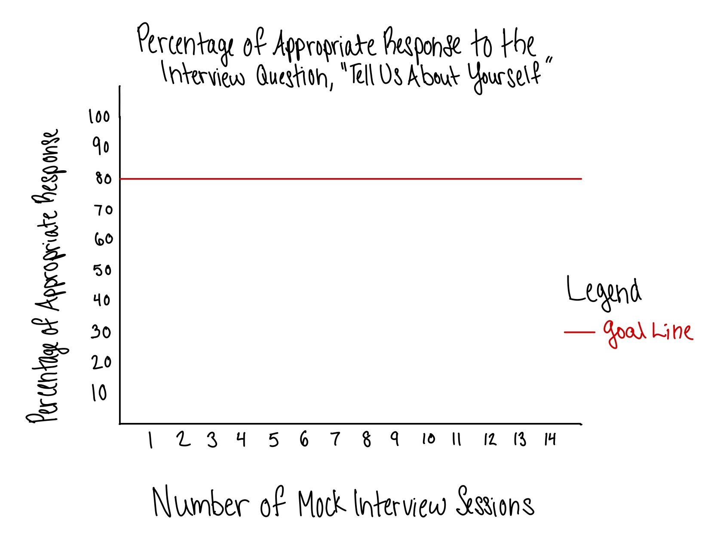
List of EBPs
There are two main evidence-based practices that will be used in this lesson plan. The first is a social narrative. Social narratives are short, descriptive stories that explain social situations, expected behaviors, and appropriate responses. They are often used to help individuals understand and navigate social interactions by providing clear examples and explanations. They can be written in first- or third-person and may include text, pictures, or both. Social narratives are an effective choice for teaching this target skills because it clarifies expectations by explaining what an interview is, why it is important, and what the interviewer expects in a response. It provides a step-by-step guide, breaking down the process of answering the question into clear, manageable actions. Social narratives can also reduce anxiety by allowing the students to preview the experience and encourages self-regulation by referring to the narrative before an interview to reinforce learning and practicing their response.
The second EBP that will be used in this lesson is scripting. Scripting is an instructional strategy where students use written or verbal scripts to learn and practice social communication skills. Scripts provide structured, pre-planned language that learners can use in specific situations, helping them develop appropriate and confidence responses. The use of the script can be gradually faded as the student becomes more comfortable with spontaneous responses. Scripting is an effective choice for teaching this target behavior because it provides a clear structure for the student to organize their thoughts and present a well-formatted response. It reduces anxiety by having a prepared response rather than having to come up with something on the spot. Scripting also supports language development by reinforcing appropriate phrasing, vocabulary, and sentence structure. Finally, it encourages gradual independence as the script is faded over time, allowing the student to develop more natural responses.

Steps of Explicit Instruction, Including Reinforcement and Error Corrections
Lesson Overview
Student(s)/Grade Levels | 7 students in grades 9-12
Subject Area | English Language Arts: Speaking and Listening  Transition Skills: The Job Search
Lesson Goal | Students will develop the ability to confidently and effectively answer the interview question, “Tell us about yourself,” using structured, concise, and relevant responses that highlight their background, skills, and career goals.
Lesson Objective | Given a structure script and social narrative, students will construct and deliver a well-organized personal introduction in response to the interview question, “Tell us about yourself,” demonstrating accuracy, fluency, confidence, and adherence to a structured format with 80% proficiency as measured by a rubric.
State Standard(s) | - SL.9-10.4: Present information, findings, and supporting evidence clearly, concisely, and logically such that listeners can follow the line of reasoning and the organization, development, substance, and style are appropriate to purpose, audience, and task.  - SL.9-10.6: Adapt speech to a variety of contexts and tasks, demonstrating command of formal English when indicated or appropriate.  - SL.11-12.4: Present information, findings, and supporting evidence, conveying a clear and distinct perspective, such that listeners can follow the line of reasoning.  - SL.11-12.6: Adapt speech to a variety of contexts and tasks, demonstrating a command of formal English.
Annual Goal | By the end of the academic year, students will independently demonstrate effective interview skills by answering at least three common interview questions (e.g., “Tell us about yourself,” “What are your strengths and weaknesses?” and “Do you have any questions for us?”) with 80% proficiency in clarity, fluency, confidence, and adherence to structured responses, as measured by a rubric in at least two mock interview sessions.
Assessment | Ongoing Progress Monitoring (CBM): | Lesson Mastery:  - Performance-Based Assessment in the form of a Mock Interview: mastery benchmark of 80% or higher on the rubric.
Materials/Technology | - Rubric  - Social narrative – provided in the “Modeling (I Do)” section  - Script worksheets (provided after the lesson plan)  - Pencils and/or Chromebooks for completing the script
Accommodations/Modifications/Supports  for Diverse Learners:  Individualized Behavior Supports | - Flexible response options (written or digital scripts; use of communication devices allowed in mock interviews)  - Color-coded sections in the script to help students organize their responses  - Prompting and reinforcement  - Extra time if needed

Lesson Procedures
Anticipatory Set/Background Knowledge:  - Agenda  - Share lesson objective  - Behavior expectations  - Background knowledge/Review routines  Page #: N/A, Time: 3-5 minutes | Agenda/Daily Activities:  - Review agenda for the lesson with students.  “Today I am going to read you a social story about answering the interview question, ‘Tell us about yourself.’ Afterward, we will work together to complete a script so you can answer the question yourself. Finally, we will practice with mock interviews, so you are prepared to answer the question at your first real interview.”  Lesson Objective:  - Review the lesson objective in student-friendly language.  “By the end of the lesson, you will create and present a well-organized introduction to answer the interview question, ‘Tell us about yourself’ that can be used in real-life scenarios. You will focus on being clear, confident, and following the given structure.”  Behavior Expectations:  - Review behavior expectations for the lesson.  “During our lesson, you are expected to follow directions the first time they are given, be respectful of the person speaking, and try your best. If you have any questions, please raise your hand.”  Background Knowledge:  - Prompt the students to discuss the importance of our objective.  “Why do you think it is important to have an introduction prepared before going to an interview? Take a few seconds to think about it, and we will turn to a partner to discuss before sharing with the class.”  - Allow the students to think-pair-share their responses to the question. Guide the discussion in the direction of “It’s important because the introduction is the employer’s first impression of you and helps them decide if you would be a good fit for the job.”
Modeling Activities (I do):  Page #: N/A, Time: 5-10 minutes | Modeling (I do):  - Read the provided social story below.  Alex Aces the Interview  Alex is in high school and is having his very first job interview at his local grocery store. An interview is a meeting where an employer talks to a person who wants the job. They ask questions to learn about their skills, experiences, and goals. The most common first question is, “Tell us about yourself.” Why would the employer ask this? They ask this question because they want to get to know you. Their goal is to learn about who you are, what you have done in school or work, what skills you have, and what you would like to do in the future. This question helps them decide if you would be a good fit for the job.  Alex is nervous because he doesn’t know how to answer this question, so he sits down to practice with his teacher. His teacher gives him a script to help guide his answers. This script includes opportunities to talk about his name, experience, skills, interests, and goals. Working together with his teacher, they write down his answers and practice saying it out loud. Alex focuses on using a calm voice and takes deep breaths when he feels nervous. His teacher gives him feedback, reminding him to use appropriate eye contact and show confidence, as well as to keep his answer short.  After practicing so many times that he doesn’t need the script anymore, Alex is finally ready for his interview at the grocery store. He enters the office and shake the interviewer’s hand before sitting down. Just as he expected, the first question the interviewer asks is, “Tell us about yourself.” Although he’s still a little nervous, Alex knows he can do it. Confidently and clearly, he responds, “My name is Alex, and I am a senior at Anyville High School. I have experience volunteering in our school library, where I learned customer service and problem-solving skills by using our online catalogue system to help students find different books throughout the library. I am good at helping people find what they need, and I enjoy making sure customers have a good experience by greeting them with a smile and my positive demeanor. I want to work in sales and marketing, and I believe that this job at the grocery store will help me improve my skills and grow in the field.”  The interviewer looks very impressed, and Alex knows he aced it! This makes him feel well-prepared for the rest of the interview. The next day, he gets a phone call from the store manager who offers him the job. Alex graciously accepts and cannot wait to thank his teacher for all of their help preparing his answer to that very important first question.  - Discuss key takeaways, such as tone, clarity, and professionalism.  - Ask the students to identify how Alex’s response is effective.  “What do you think made Alex’s answer to the question stand out to the employer? Was there anything specific you noticed?”  - Call on students who have their hands raised to share what they noticed.
Guided Practice Activities (We do):  - Practice items  - Correction procedures  - Release of control  Page #: Script Template, Time: 15-20 minutes | Guided Practice Activities (We do):  - Pass out scripts to students who prefer to use pencil and paper.  - Direct students who prefer to complete assignments digitally to open the document on Google Classroom.  - Instruct student to put their name and date at the top of the page.  - Walk them through each section of the template.  “The first section is the introduction, and it’s highlighted in red. In the first blank, write your name. In the second blank, write your current role. This would be your grade in school. After writing your response, check in with a partner to see what they wrote.”  - Walk around to each student to check what they’ve written, providing verbal corrections when needed. Provide verbal praise if correct.  “The next section is your background experience, and it is highlighted in orange. For the first blank, write the name of our school. In the second blank, write any work or volunteer experience you have. Finally, on the third blank, write about some of your interests that you had during that experience. After writing your response, check in with a partner to see how their answers compare to yours.”  - Walk around to each student to check what they’ve written, providing verbal corrections when needed. Provide specific verbal praise if correct. (Example: “I really like how you wrote about the time that we volunteered in the kitchen together. That was a lot of fun and a great experience to show how well you work with others.”)  “The third section is where you discuss your skills, and it is highlighted in green. Try to think of things that are related to the job you want to interview for and write about when or how your learned that skill. Give specific examples to show what you’ve learned. You can work with a partner to brainstorm some ideas about what you are good at.”  - Walk around to each student to check what they’ve written, providing verbal corrections when needed. Help guide group discussion/brainstorming toward skills that are relevant to the student’s goal/job. Provide specific verbal praise for ideas that are relevant.  “The fourth section, highlighted in blue, is about your goals. On the first line, write a future goal that you have, and on the second line, write the ways that you think the job you are interviewing for could help you reach that goal. Again, you may work together to brainstorm ideas for this.”  - Walk around to each student to check what they’ve written, providing verbal corrections when needed. Help guide group discussions/brainstorming toward goals that relate to the job they are interviewing for and provide praise for ideas that are relevant.
Independent Practice (You do):  - Practice items  - Correction procedures  Page #: Complete Script Templates,  Time: 25-30 minutes | Independent Practice (You do):  - Instruct students to practice reading their completed script on their own.  “You will have 5 minutes to practice reading your script on your own. I will then come around for a mock interview with each of you, where you will present your response to me. I want you to focus on speaking slowly and clearly with confidence.”  - After allowing them 5 minutes to practice, go to each student to hear their response.  - If correction is needed during their mock interview, give the student gestural prompts toward the section they are on in their written script.  - Using the rubric, score the student’s mock interview accordingly, and give verbal feedback about what went well, what could go better, and one thing that stood out to you.
Closure:  - Cumulative review  Page #: N/A, Time: 3-5 minutes  - Review lesson objective  - Preview next lesson’s topic/content | - Review why interviewers ask people to “Tell us about yourself.”  - Ask students to share what they’ve learned; call on students with their hands raised.  - Guide to discussion towards key elements of the interview response, such as introduction, background experience, skills, and goals, as well as speaking clearly and confidently.  - Review lesson objective, praising students for successfully completing a script and encouraging them to continue practicing their responses, because in the next lesson they will learn how to formulate a response to the question, “What are your strengths and weaknesses?”

Script Template
Name: __________________________________________________________________ Date: _____________________________________
Directions: Complete the following template to the best of your ability. You may work together with your peers to brainstorm your answers.
My name is ___________________________ and I am currently __________________________
YOUR NAME CURRENT ROLE
______________________________________________________________________________.
CURRENT ROLE CONTINUED

I have experience at ____________________________ and _____________________________
SCHOOL WORK/VOLUNTEER EXPERIENCE
where I enjoyed ________________________________________________________________.
RELEVANT INTERESTS

I am good at _____________________________ which I learned when I ___________________
RELEVANT SKILL #1 WHEN/HOW YOU LEARNED SKILL #1 ______________________________________________________________________________.
WHEN/HOW YOU LEARNED SKILL #1 CONTINUED
I am also skilled at ________________________, which is something I practiced when I
RELEVANT SKILL #2
______________________________________________________________________________.
WHEN/HOW YOU LEARNED SKILL #2
Finally, I am great at __________________________________, which I developed when I
RELEVANT SKILL #3
______________________________________________________________________________.
WHEN/HOW YOU LEARNED SKILL #3.

I am excited to _______________________________________ and believe this job will help me
FUTURE GOAL
______________________________________________________________________________.
CONNECT JOB TO GOAL

