Impact on Student Learning

Contextual Factors

Community
County: Van Buren County
ISD: Van Buren Intermediate School District
City/Village/Township: Paw Paw, MI
District: Paw Paw Public School

Description of Community
Paw Paw, Michigan is a small village in Van Buren County with a population of approximately 3,300 residents, according to the 2023 U.S. Census Bureau. The community is minimally diverse, with 80% of residents identifying as White and only 11% identifying as Hispanic, 6% as Mixed-Race, 2% as Black, and 1% as Asian. The population’s sex is evenly split 50/50 for male and female. The median age is 35 years old, with 25% under 18, 58% between 18 and 64, and 17% 65 years or older. 94% of residents have graduated high school or completed higher education, with 39% completing some college, 9% with a bachelor’s degree, and 2% completing post-graduate degrees. The median household income is around $39,000, well below the state average of $71,000, with 26% of children and 20% of seniors living below the poverty line. There are about 1,500 housing units in the village, almost equally split between renter-occupied and owner occupied, 52% and 48%, respectively (U.S. Census Bureau, 2023).
Several cultural characteristics stand out in the community. Paw Paw is known for its vineyards and wineries, including St. Julian Winery, which is the oldest in the state of Michigan. There is an annual Wine and Harvest Festival to celebrate its agricultural roots and fostering community spirit. In addition to this, there are a handful of community events throughout the year, such as farmers’ markets, parades, and seasonal celebrations that attract visitors and locals alike. There is a major focus on education, with Paw Paw Public Schools serving local families and emphasizing academics, arts, and extracurricular activities. There are various recreational opportunities as well, such as enjoying local parks, lakes, and trails providing year-round entertainment. Maple Lake and other nearby natural environments are popular for fishing, kayaking, and picnicking.

Description of District
Paw Paw Public School District serves the educational needs of students from the local community and surrounding rural areas, from early childhood through graduation, at the Early Elementary, Later Elementary, Middle School, High School, and Cedar Street Campus. They are actively building an Early Childhood Center, as well. Each school follows Michigan’s state standards and focuses on strong foundational skills in math, reading, science, and social studies. They also offer Advanced Placement and honors courses at the high school for students who are seeking advanced academic challenges. Students also have the opportunity to pursue Career and Technical Education, where they explore vocational and technical career paths to help prepare them for further education or the workforce. Finally, Paw Paw Public School District is committed to supporting students through special education services, providing inclusive education and resources for students with disabilities.
Paw Paw Public Schools has a strong athletics program with a wide variety of sports, such as football, basketball, soccer, volleyball, baseball/softball, track, wrestling, bowling, and more. The mascot was recently updated to the Red Wolves, and students show a lot of school pride. The district also supports arts education, including band, choir, theater, and visual arts programs. In addition to all of this, there are also several clubs and organizations to encourage leadership, community involvement, and personal growth.
There is a large commitment to community involvement and student excellence, valuing parental involvement, partnerships with local businesses, and many volunteer opportunities. Concerts, sporting events, and other student activities are well-attended by the residents of Paw Paw. The district’s mission focuses on creating a safe, inclusive, and engaging learning environment where students can thrive academically, socially, and emotionally. It emphasizes preparing students for success in college, careers, and as contributing members of society. PPPS aims to foster a sense of pride and achievement among students while maintaining a close-knit, supportive environment characteristic of the village it serves.

Impact of Community Context on your Classroom
Paw Paw, Michigan's community and district context significantly impacts instruction in our high school special education classroom by shaping the needs, resources, and opportunities available to students. Instruction must be inclusive, supportive, and career/life skills-focused while addressing diverse learning needs. Because of a low median household income, it is important to utilize trauma-informed teaching. Understanding that financial instability can contribute to stress, absenteeism, or unmet basic needs, instruction must incorporate social-emotional learning strategies to support student well-being. Some students may lack internet access or personal devices at home, so instruction should prioritize in-school access to technology and differentiated resources to ensure equity. Instructional planning should also focus on real-world applications to help students stay engaged while managing outside responsibilities.
Paw Paw’s rural setting and strong community connections also influence how instruction is structured. The close-knit nature means students and families are highly involved. We emphasize family partnerships, regular communication, and community-based learning opportunities. Many of our students need explicit instruction in communication, self-advocacy, and life skills to navigate social and professional settings. Given the town’s limited diversity, instruction should also incorporate multicultural awareness and inclusive practices to prepare students for diverse environments beyond Paw Paw. The district’s commitment to community engagement allows for work experience and expanding our micro-enterprise, helping students practice real-world skills in a supportive, familiar setting. We also utilize an objectives-based curriculum to help prepare students to prepare for the community-based transition center, where most of them will continue to learn until the age of 26.

School

Description of school and classroom
Paw Paw High School serves students in ninth- through twelfth-grade. There are 34 teachers, three members of support staff that serve as paraprofessionals, and four members that provide related services. Special programs include our micro-enterprise, where students make dog treats and toys that can be sold throughout the community. There are several programs offered for students with disabilities, including elementary and secondary-level resource rooms, programs for moderate cognitive impairment, severe cognitive impairment, and the Community-Based Transition Center for students after high school through the age of 26.
My classroom consists of students who have a variety of disabilities, including cognitive impairment, speech and language impairment, autism spectrum disorder, and other health impairments. Our demographics include students that are white, Asian, and two or more races. Four of our students are male, and three are female. All of the students in our building receive free breakfast and lunch.
I am placed in the high FTE special education room, which comprises three conjoining classrooms. The main classroom, placed in the middle, is where most of the teaching and learning takes place. There are visuals related to our current objectives on the walls, as well as specific places to keep materials for each hour. Each student has their own space at a desk or table, as well as a basket to keep the items they are working on. The teacher’s desk is located at the front and is easily accessible by everyone in the room when they need assistance. There is a TV screen at the front of the room by a whiteboard to project visuals from the computer.
One of the conjoining rooms is a kitchen where students can practice life skills, such as cooking, baking, and washing dishes. They bake dog treats as part of an entrepreneurial program. There is also a washing machine and dryer, where students can practice doing laundry. They assist several classes throughout the building by cleaning materials that they may need, especially towels for art and P.E.
There is a small office between the main classroom and the final room. Paraprofessionals store their items in the office, pre- and post-assessment materials, and student data are organized in filing cabinets. The final room is where students may go to work on things that they may have missed, engage in 1:1 instruction with a teacher or paraprofessional, as well as making dog toys as part of the previously mentioned entrepreneurial program.

Table 1: Demographic
Characteristic | N School | N Classroom
All students | 665 | 7
Black/African American | 7 | 0
2 or More Races | 20 | 2
White | 570 | 4
Hispanic | 61 | 0
Native/American Indian | 1 | 0
Asian | 6 | 1
Female | 319 | 3
Male | 346 | 4
Free and Reduced Lunch | All | All
Multilingual | 11 | 0

Table 2. Disabilities
Disability Category | N School | N Class
Cognitive Impairment | 3 | 2
Emotional impairment | 0 | 0
Deaf or Hard of Hearing | 0 | 0
Visual Impairment | 1 | 0
Physical Impairment | 0 | 0
Other Health Impairment | 15 | 3
Speech and Language Impairment | 19 | 3
Developmental Delay | 0 | 0
Specific Learning Disability | 28 | 0
Severe Multiple Impairment | 0 | 0
Autism Spectrum Disorder | 10 | 2
Traumatic Brain Injury | 0 | 0
Deaf-Blindness | 0 | 0

Impact of school/classroom context on Instruction:

The demographics, disability status, and school culture significantly shape instruction, expectations, and student experiences in our high school special education classroom. These factors influence my approach to lesson planning, student engagement, behavior management, and post-secondary preparation. With only seven students, I can implement highly individualized instruction, focusing on each student’s unique strengths, needs, and learning goals. With a diverse group in our classroom, we include intentional multicultural exposure to help students develop cultural awareness and prepare for interactions beyond their local community. We also ensure that students’ basic needs are met before focusing on academics, teach financial literacy, and independent living skills to help students navigate real-world challenges.
Because of their diverse learning needs, we utilize differentiated instruction, individualized supports, and multimodal teaching strategies, such as visual support, structured routine, communication supports, and frequent breaks and sensory accommodations. Given the nature of their disabilities, instruction goes beyond traditional academics. There is a heavy emphasis on daily living skills in our kitchen and laundry area, social and communication skills, and vocational skills development through the micro-enterprise program. All of our current students will transition into the CTC rather than traditional college pathways, so we incorporate field trips within the community, work experience, and real-world practice of life skills to help students generalize their abilities both in and outside of school.

Student(s)

Target Student Description
Initials/grade | Disability and Demographic Information | Assessment Results  (List assessments and results) | IEP Goals
K.C., 10th grade | 16-year-old Mixed Race (Hispanic & White) female; Cognitive Impairment | WISC-V:  - Verbal Reasoning: 62; 1st%ile  - Fluid Reasoning: 58; 0.2%ile  - Full Scale IQ: 56; 0.1%ile  Subtest Scaled Scores:  - Block Design: 5; 5%ile  - Similarities: 3; 1%ile  - Matrix Reasoning: 1; 0.1%ile  - Digit Span: 2; 0.4%ile  - Coding: 6; 9%ile  - Vocabulary: 3; 1%ile  - Figure Weights: 4; 2%ile  KTEA-3:  - Reading Comprehension: 61; 0.5%ile  - Math Concepts & Applications: 62; 1%ile | K will show she can comprehend written text by answering comprehension questions, stating a theme, and identifying the author’s purpose with 80% accuracy by April 2025.  K will complete the punctuation and grammar skills objectives with at least 70% accuracy by April 2025.  K will be able to solve linear one step and multi-step equations in one variable with 80% accuracy by April 2025.  K will complete the job pre-requisite and meal preparation objectives with at least 70% accuracy by April 2025 for her to learn how to cook a variety of meals for herself, and so she will gain the necessary pre-requisite job skills to help her obtain part-time employment.
T.H., 9th grade | 15-year-old Korean female; Other Health Impairment - Alcohol Related Neurodevelopmental Disorder | KTEA-3:  - Academic Skills Battery: 66; 1%ile  - Reading Composite: 69; 2%ile  - Letter & Word Recognition: 81; 10%ile  - Reading Comprehension: 60; 0.4%ile  - Math Composite: 59; 0.3%ile  - Math Concepts & Applications: 58; 0.3%ile  - Math Computation: 63%ile  - Writing Composite: 75; 5%ile  - Written Expression: 69; 2%ile  - Spelling: 82; 12%ile  WISC-V:  - Full Scale IQ: 58; 0.3%ile  - Verbal Comprehension: 68; 2%ile  - Visual Spatial: 64; 1%ile  - Fluid Reasoning: 69; 2%ile  - Working Memory: 62, 1%ile  - Processing Speed: 53; 0.1%ile  Vineland-3  - Adaptive Behavior: 60; <1%ile  - Communication: 60; <1%ile  - Daily Living Skills: 59; <1%ile  - Socialization: 63; 1%ile | T will complete the comprehension and receptive language objectives with at least 70% accuracy by 9/23/2025.  T will complete the punctuation and spelling objectives with at least 70% accuracy by 9/23/2025.  T will complete the time and computation objectives with 70% accuracy by 9/23/2025.  T will complete the V/WA-3 job pre-requisite and laundry objective with at least 70% accuracy by 9/23/2025.  T will demonstrate social inference by interpreting social cues found in videos, hypothetical scenarios, pictures, and text by stating what someone might be thinking or feeling and describing what clues helped her to arrive at her conclusion in 4 out of 5 opportunities with minimal prompting by 9/23/2025.
B.H., 10th grade | 16-year-old White male; Cognitive Impairment | Wechsler Intelligence Scale for Children:  - Verbal Comprehension: 65  - Visual Spatial: 69  - Fluid Reasoning: 55  - Working Memory: 55  - Processing Speed: 45  - Full Scale IQ = 51  Kaufman Test of Educational Achievement:  - Letter & Word Recognition: 40  - Reading Comprehension: 68  - Math Concepts & Applications: 62  - Math Computation: 47  - Spelling: 41  Vineland Adaptive Behavior Scales:  - Daily Living Skills: 50  - Socialization: 90 | B will complete the decoding and comprehension objectives with at least 80% accuracy by 3/11/2025.  B will be able to write his name and address with 75% accuracy, 3 out of 4 attempts, by 3/11/2025.  B will solve simple addition and subtraction problems without a calculator with 70% or better accuracy and problems including a calculator with 80% or better accuracy as measured by in-class assignments and teacher-made assessments by 3/11/2025.  B will complete the job pre-requisite and meal preparation objectives with at least 70% accuracy by 3/11/2025.

Implications for Instruction and Assessment
Since my students are in high school and actively participating in transition planning, they must develop the skill of identifying, managing, and solving equations with money. This skill is essential because financial literacy is a fundamental aspect of independent living. My students will need to understand and apply money skills in real-world scenarios, such as grocery shopping, dining at restaurants, budgeting personal finances, and handling transactions in a work setting. Without a foundational understanding of money, they may struggle with day-to-day financial decisions, which could impact their ability to live independently or succeed in vocational settings.
Given my students’ diverse learning needs and the fact that our district follows an objective-based curriculum that focuses on life skills, I need to make sure that our instructional goals align with their long-term needs. The assessment method was chosen to accommodate their learning styles while effectively measuring their progress. The pre-assessment was designed to gauge their initial knowledge of coin identification and addition, highlighting areas where more explicit instruction was necessary. Throughout the unit, formative assessments, including verbal questioning, matching activities, and hands-on manipulation of real coins, will provide on-going feedback. The summative assessment will focus on their ability to add coins accurately, serving as a progress monitoring tool within a larger unit rather than an overarching test.
The specific needs and characteristics of my students will add implications in several ways. Because many of my students have cognitive impairments, they require structured, repetitive instruction with real-world applications. Instead of abstract math problems, lessons will incorporate tangible, hands-on activities with physical coins and reference sheets to help solidify learning. The instruction design will allow for scaffolding, peer-assisted learning, and one-on-one support. Additionally, given the economic hardships within the community, it is even more critical that instruction is supportive, non-intimidating, and focused on empowering students with real-life financial skills rather than just academic math concepts.
By incorporating these considerations into my assessment and instructional planning, I will be able to provide meaningful, student-centered learning experiences that directly impact their ability to function independently beyond the classroom.

Goals and Objectives

Goals and Objectives
A-2 Mathematics/Money Skills
- I can identify the name and value of US currency.
- I can solve for the total value of coins and bills.
- I can solve for the total value of everyday items when given a price.
- I can read money values aloud.
- I can solve for change when given the money paid and the total price of the transaction.
- I can calculate the total cost when given the price and percent of sales tax.
- I can identify the cost of an item when given a menu.
- I can solve for the total of items on a check when given a menu.
- I can identify the closest dollar value when given multiple prices.

These are the objectives for the entire unit, but this project will focus on three main lessons based around coins only. Bills will be added at a future date.

Rationale for selecting goals and objectives
We use the Objective-Based Curriculum to prepare students to live independently. Because of this, the objective A-2 Mathematics/Money Skills is part of our scope and sequence of learning for all students. They will need to know how to use money in real-life scenarios, such as at the grocery store, at a restaurant, and possibly at their job, depending on where they are hired. They will need to know how to identify coins and bills, manage a budget, and calculate totals including sales tax. Through this unit, students will learn how to do all of these skills through word problems, using manipulatives and other visuals, in several settings, including large groups, small groups, and individually with adult support.

Plan for communicating goals and objectives with students
To effectively communicate these goals and objectives to my students, I focus on clarity, engagement, and a connection to real-life scenarios. I will use clear and simple language, avoiding overly technical language and keeping it straightforward. I will make sure to explain the concepts in a way that aligns with the students’ existing knowledge and experiences. For example, while the objective might be identifying the value of U.S. currency, I will communicate it as, “You’ll learn how to recognize coins and what they’re worth.” Using language that feels familiar to them will make the learning objectives more accessible.
I also like to incorporate visuals and manipulatives. The use of visual aids like pictures of coins and bills, actual coins for manipulation, or interactive charts that demonstrate how money works can be extremely beneficial. I will show real coins and allow students to physically handle them, grounding abstract concepts in something tangible, making learning more concrete. This is particularly important for students who are more visual or tactile learners.
Contextualizing the learning by relating the objectives to real-world scenarios will also show the relevance of the skills being taught. For example, instead of just telling the students that they need to learn how to do this, we will connect it to our upcoming field trip, where they will be responsible for budgeting and spending their lunch money. This will help the students see that the lesson is something they will use in their day-to-day life. In addition, I will make the learning feel more meaningful by discussing the potential challenges they might face if they don’t understand the concepts, such as possibly paying too much or not having enough money for what they want to buy.
In addition to all of this, I like to engage students through questions and active participation and break down the learning process in a step-by-step manner. I encourage self- and peer-reflection, as well, allowing students to demonstrate what they’ve learned and to check their understanding. This allows them to correct their mistakes in the moment. The use of positive reinforcement and celebrating small wins can be extremely helpful for my students, as well as providing specific feedback to each student. Using group work and peer support allows them to build social learning and cooperation skills.
Finally, it is beneficial to my students to set clear success criteria. I need to be transparent about how they will know if they have achieved the objectives. For example, “By the end of this lesson, you will be able to name a set of coins correctly and tell how much they are worth. If you can do that, you will be ready to move on to the next challenge.” By communicating in a straightforward and context-driven way, students will understand the goals, feel confident in their progress, and be more likely to succeed in achieving them.

Assessment

Pre-Assessment
In addition to considering their state and district math assessments, students will take a pre-assessment. This pre-assessment is a written document where students will answer questions related to the “I can…” statements listed above. It includes fill-in-the-blanks, addition, subtraction, multiplication, coin and bill identification, reading aloud, story problems, and comparisons. The pre-assessment for the full unit is pictured below:

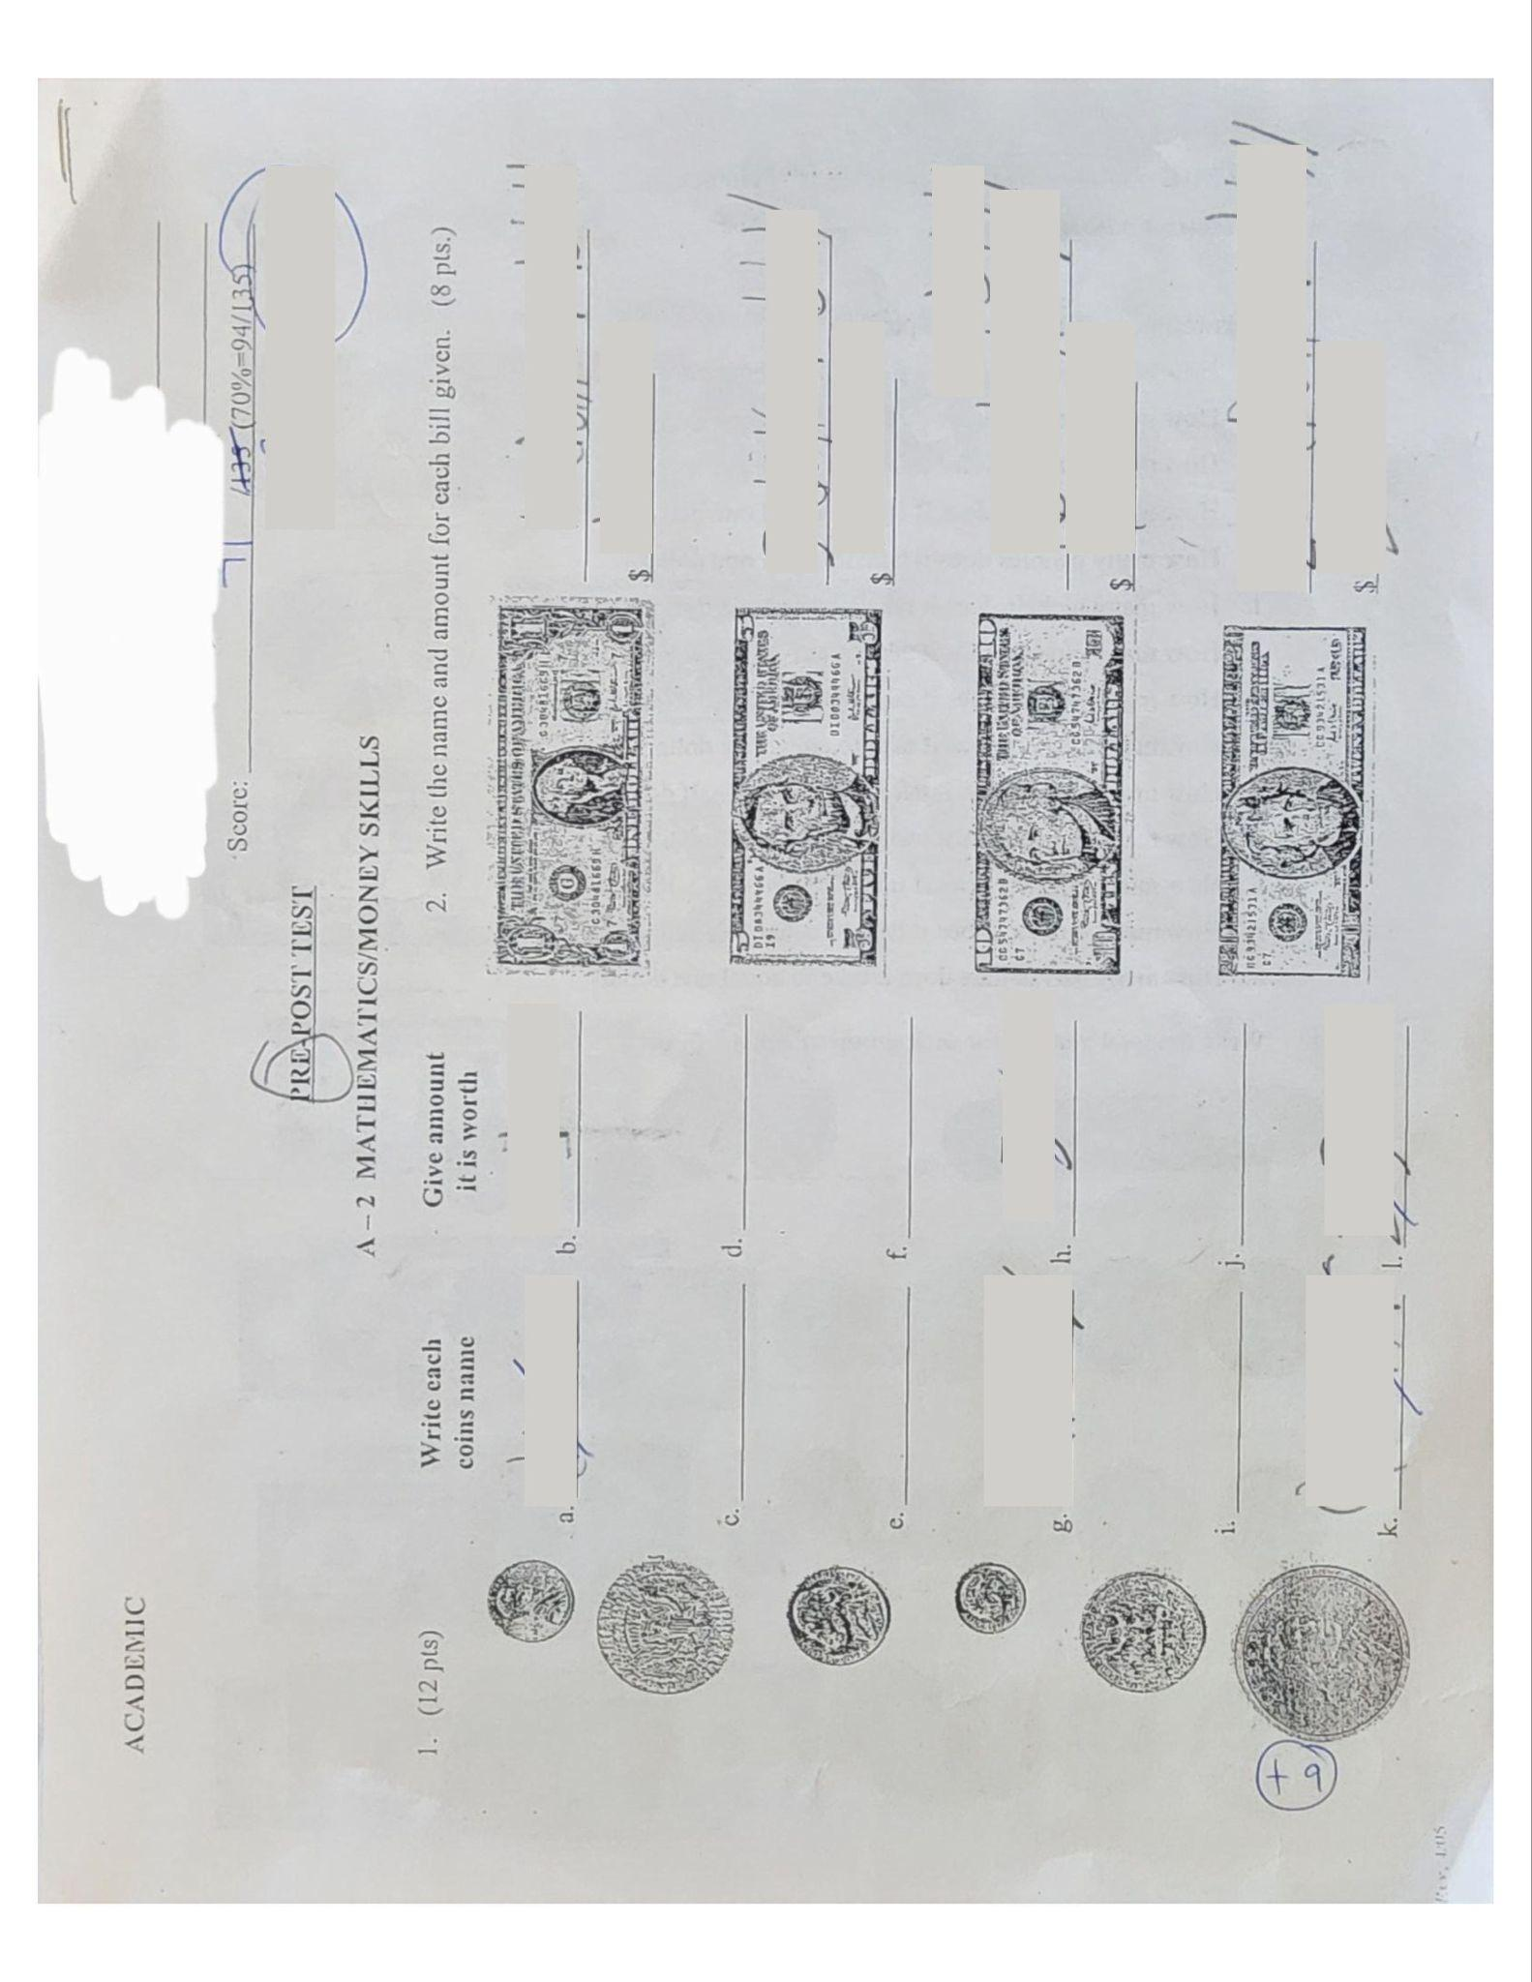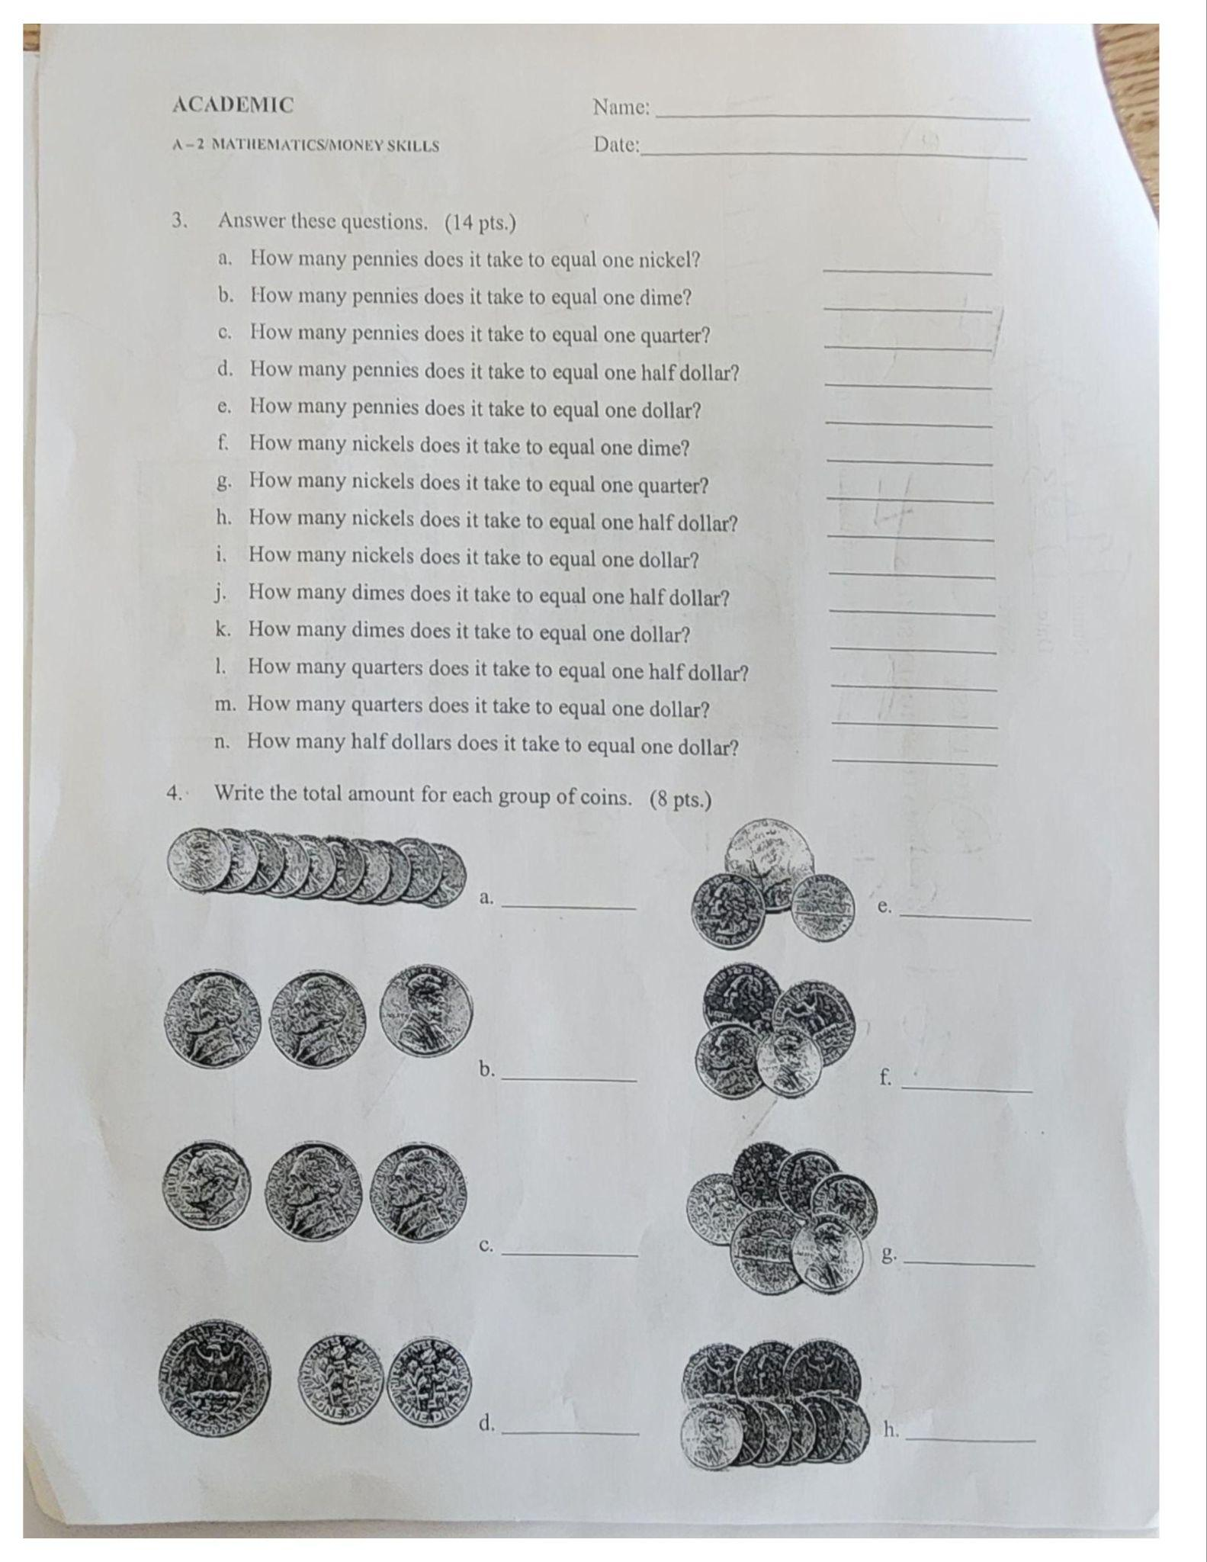
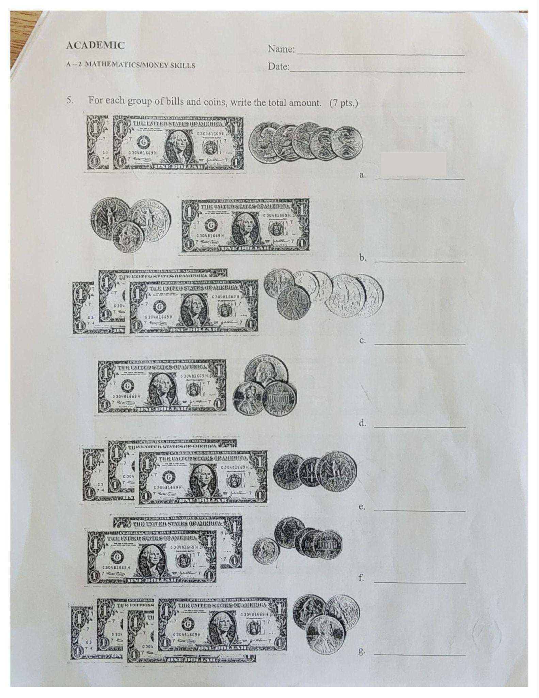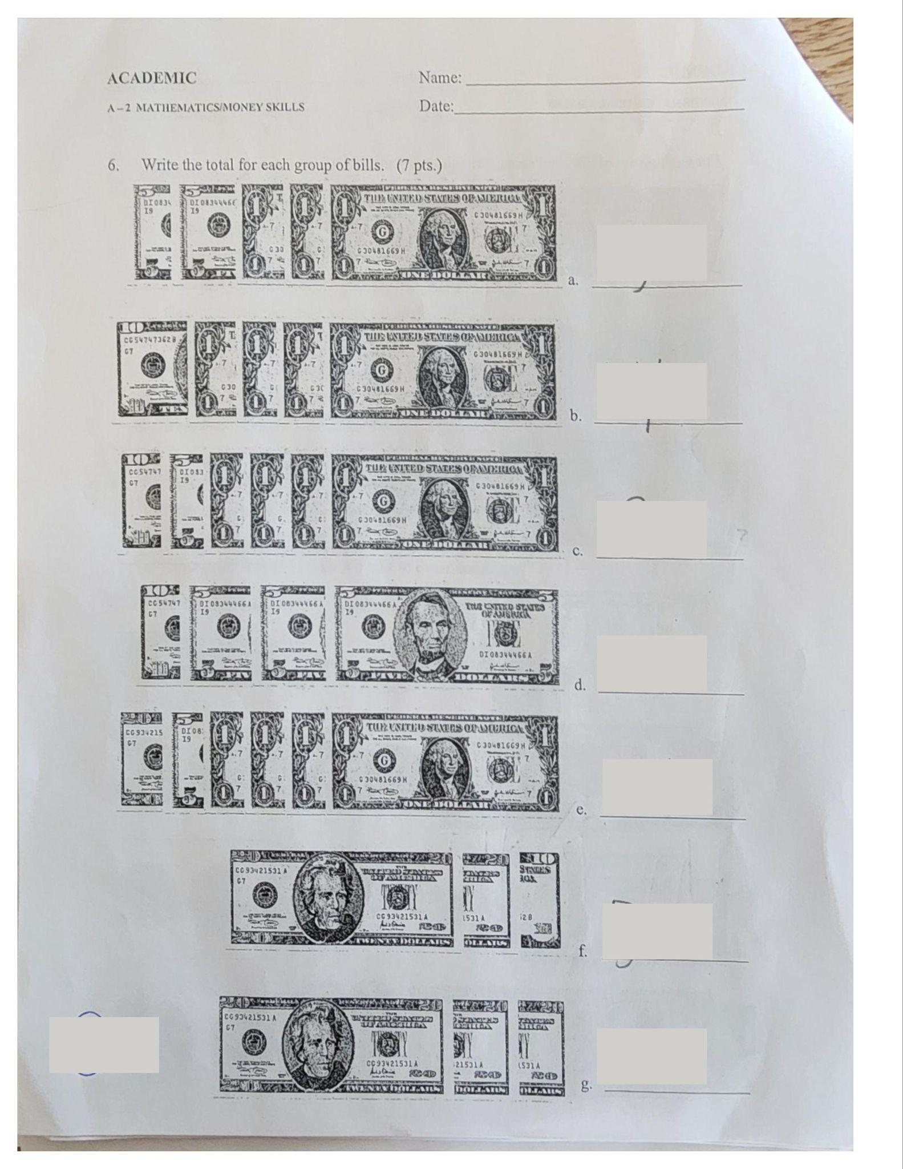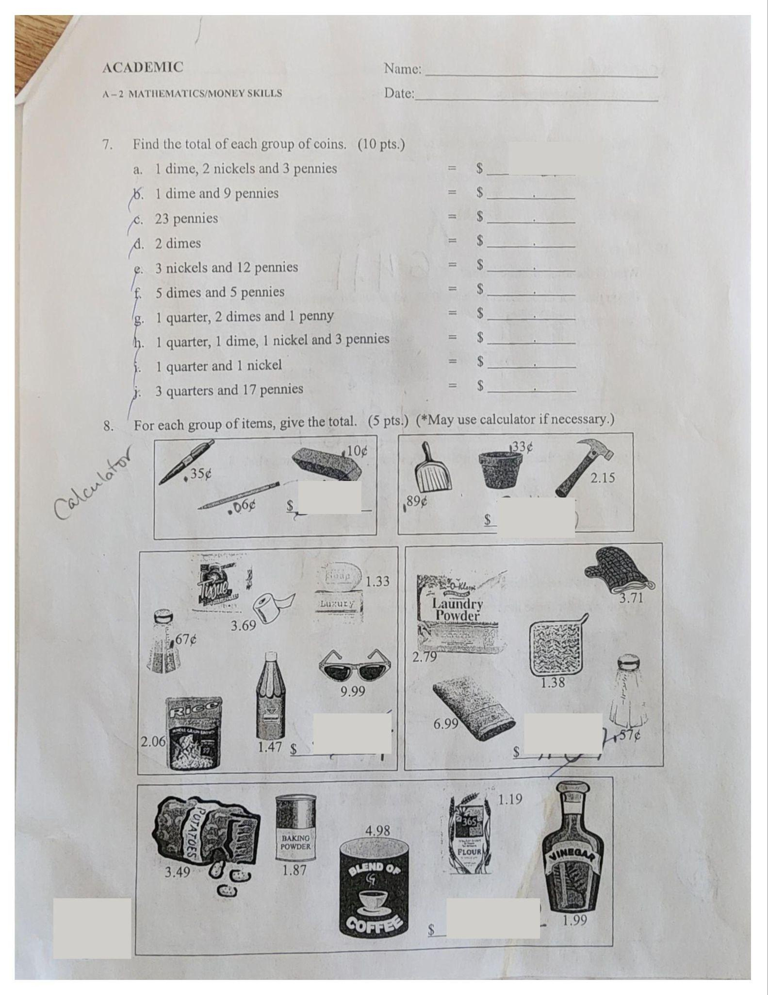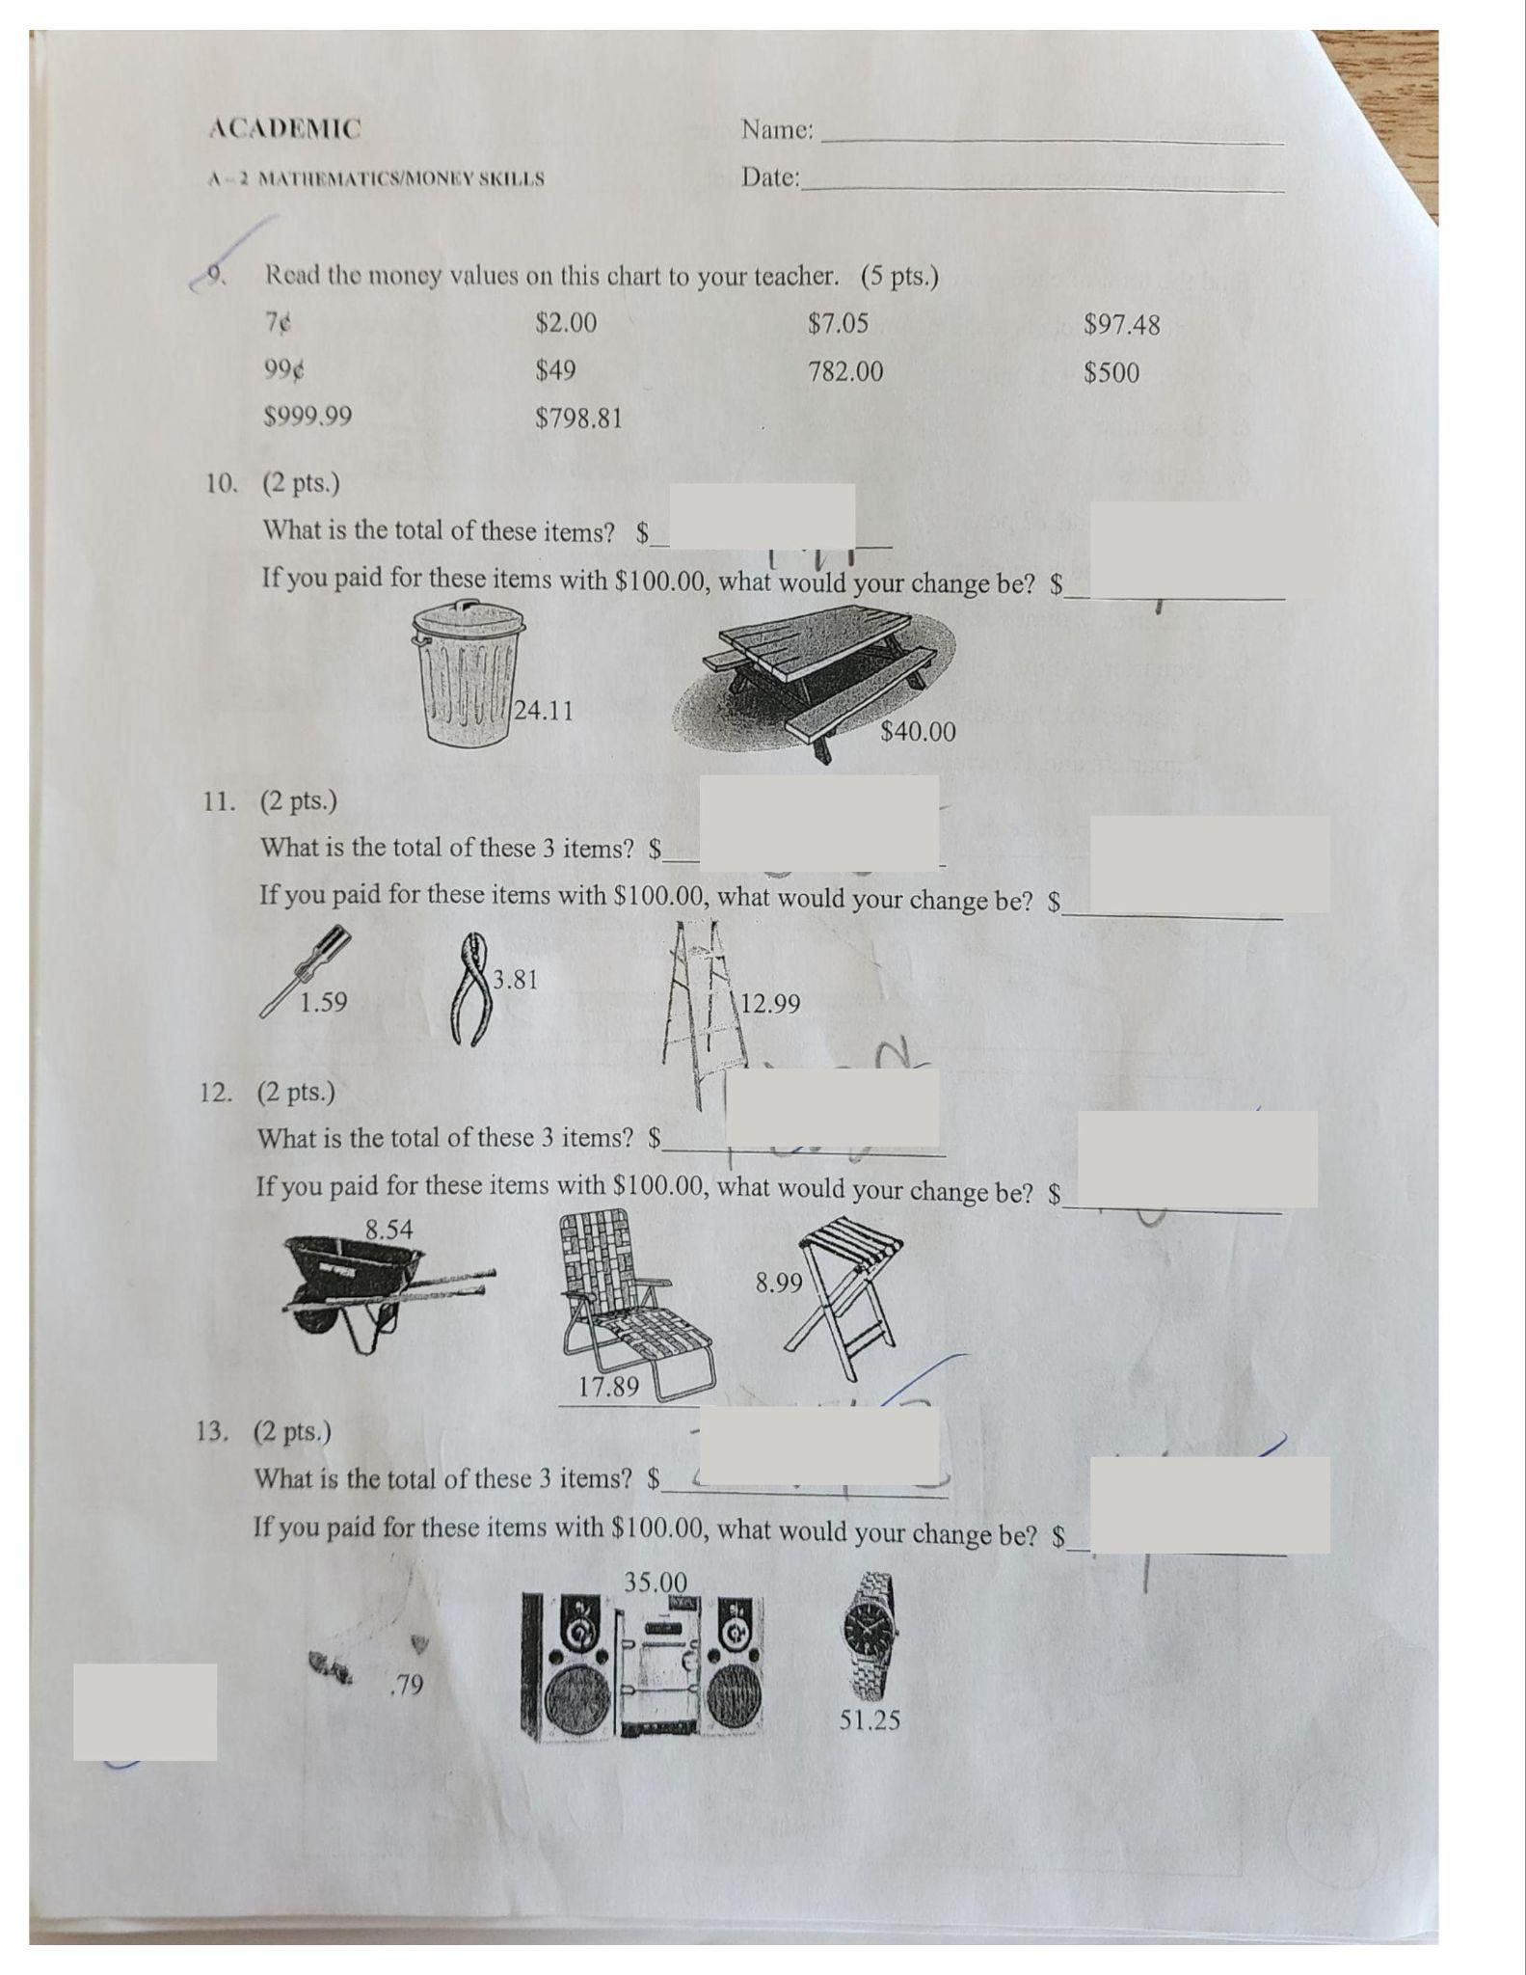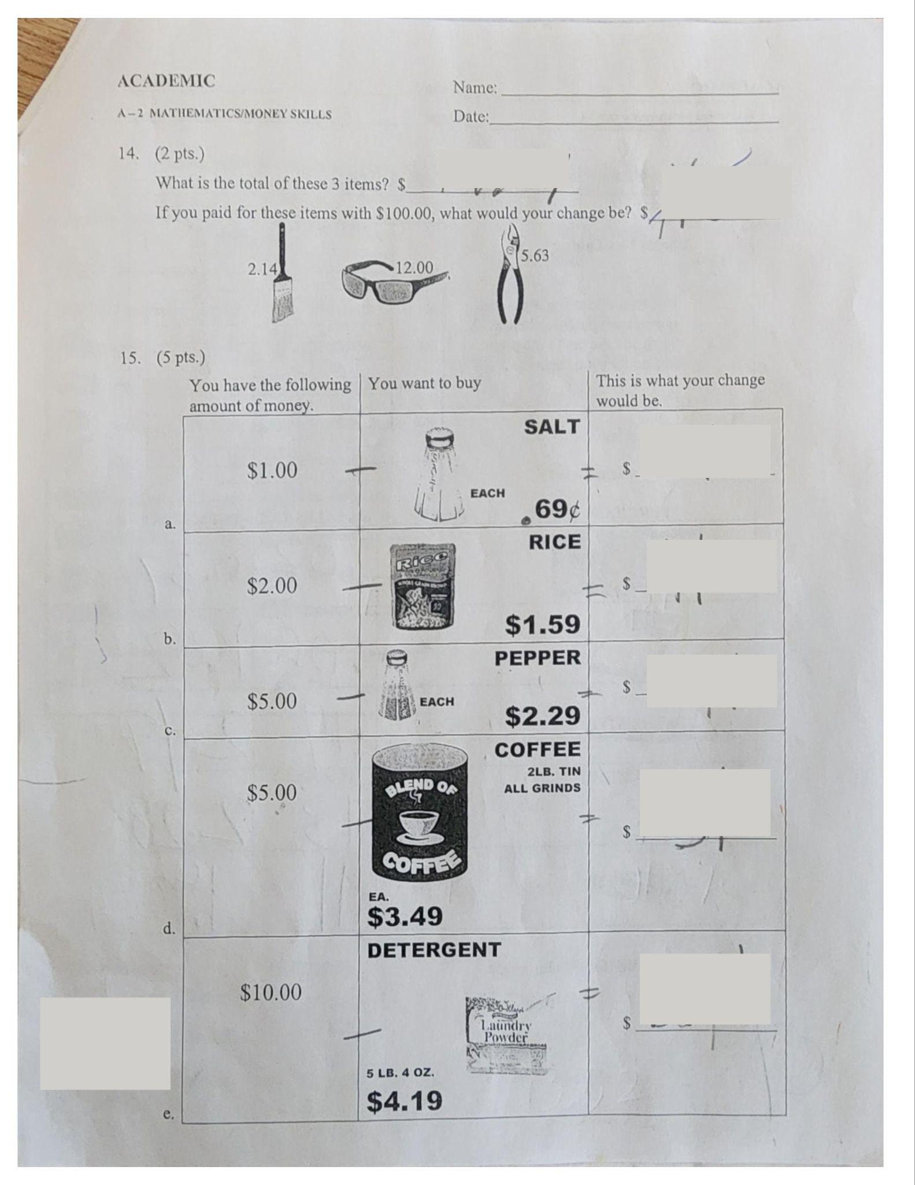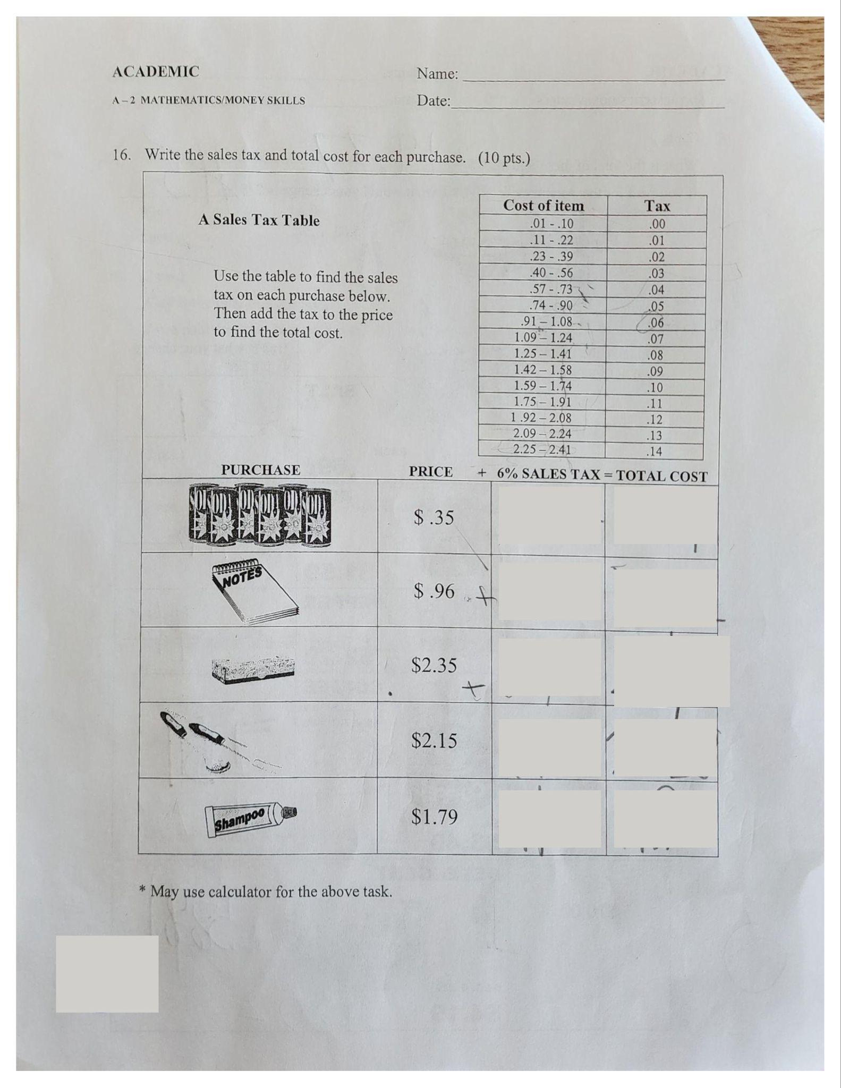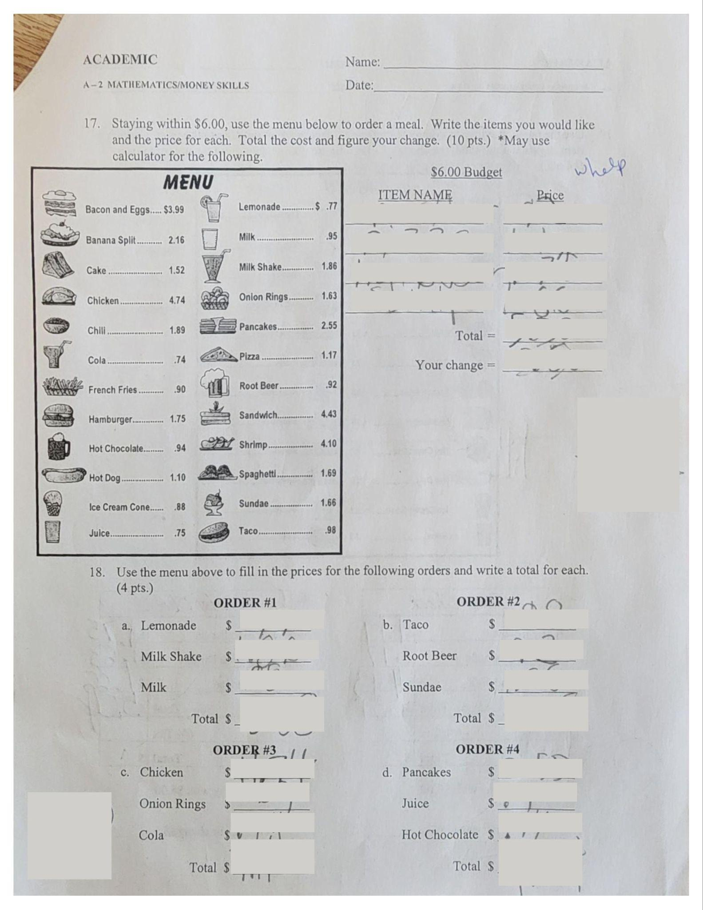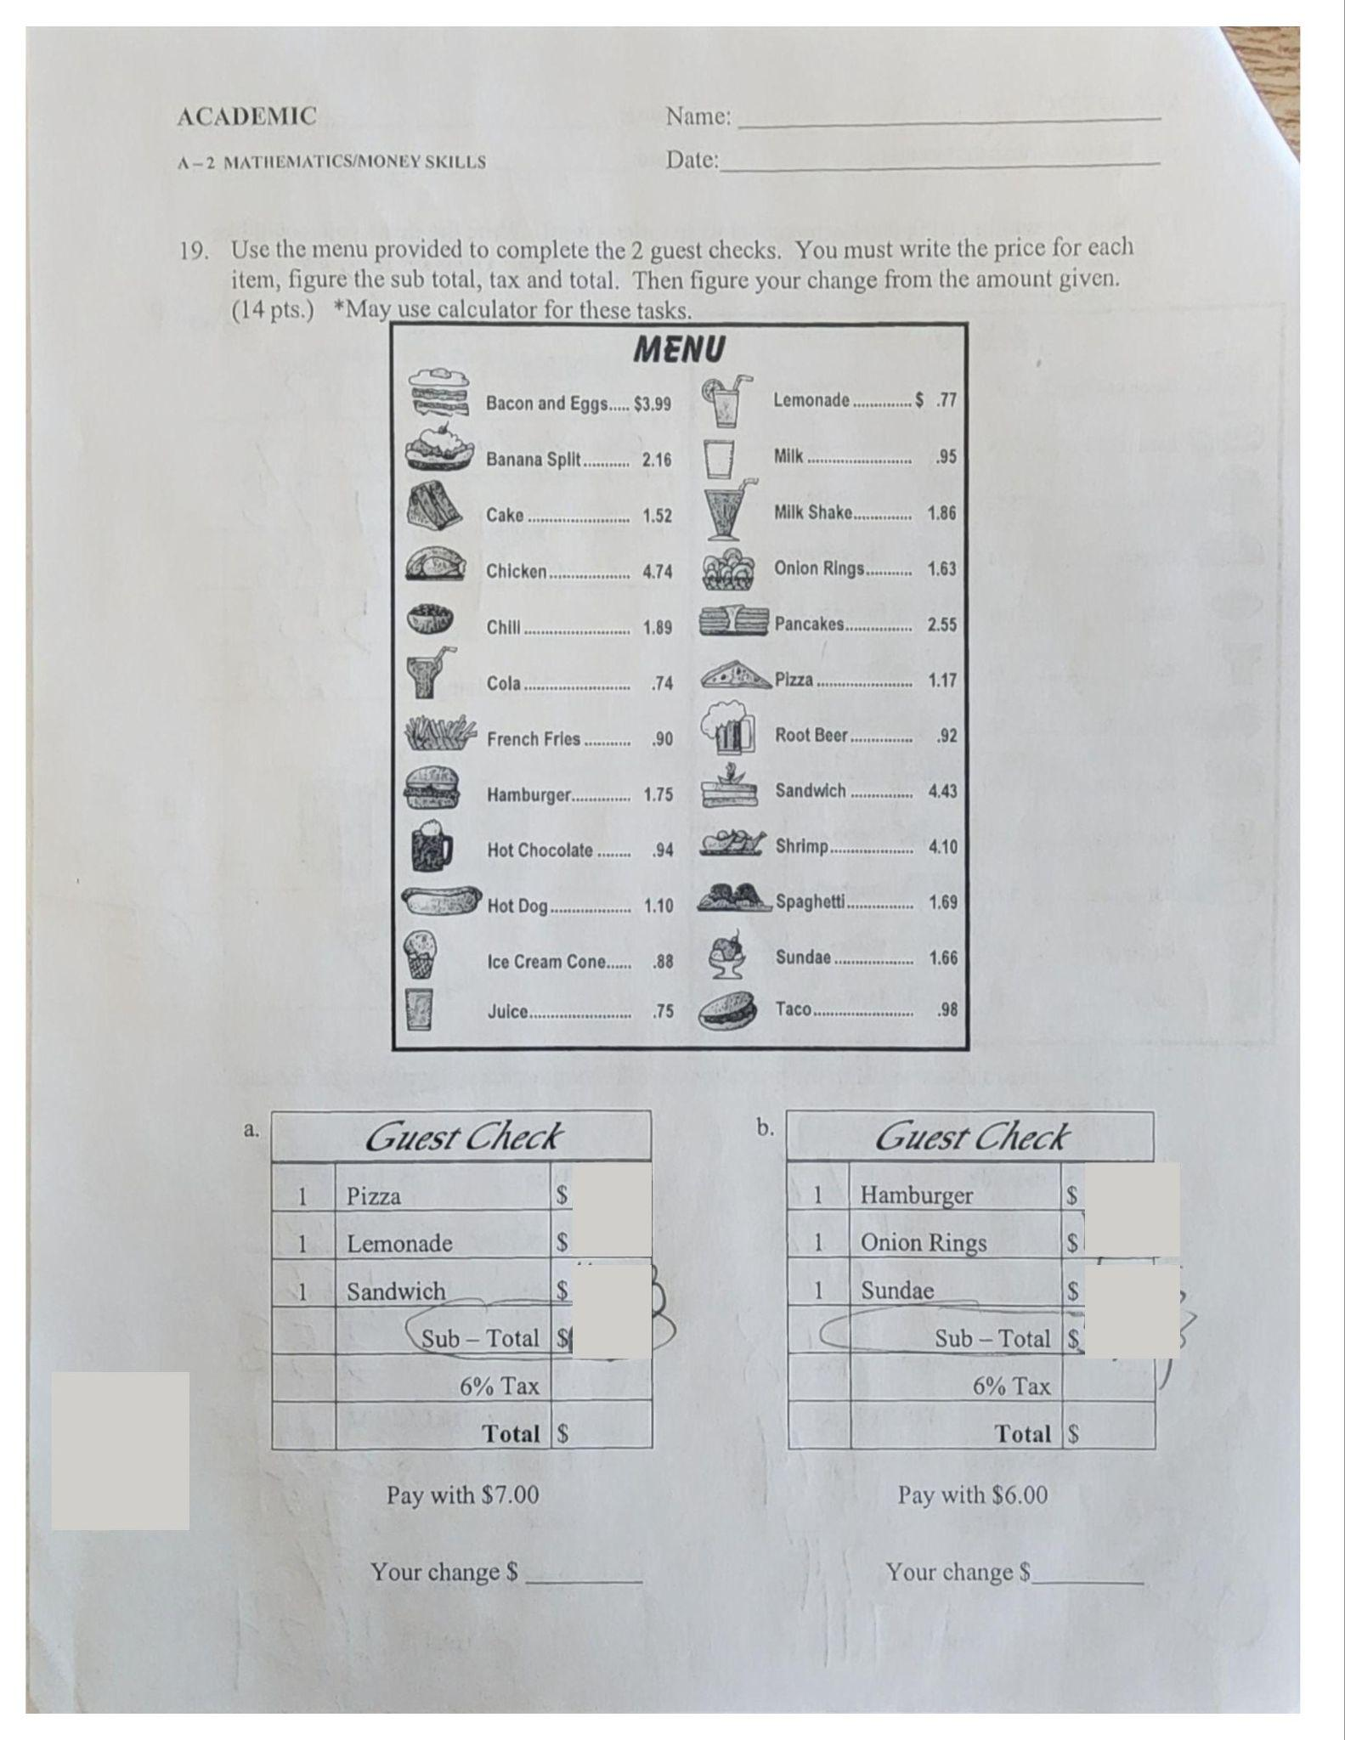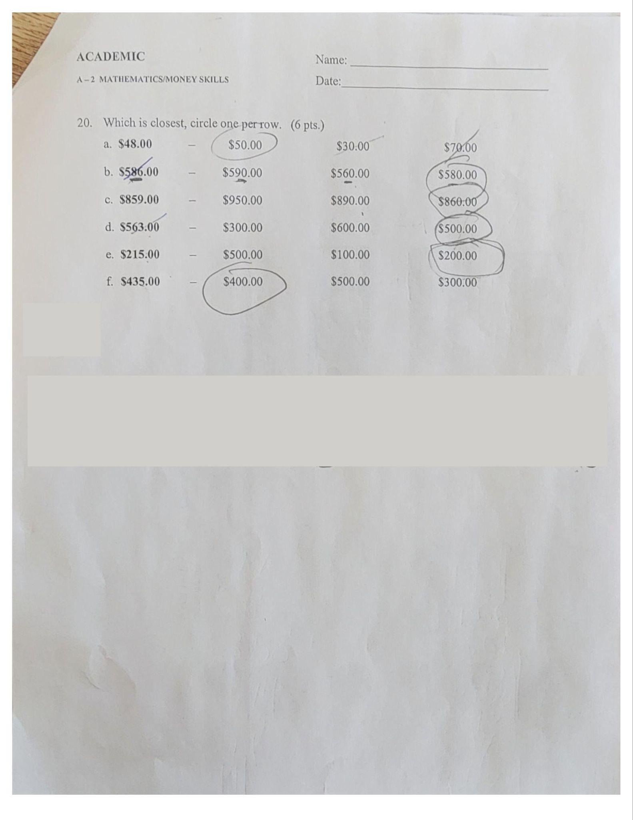

Table 3: Pre-assessment results
Student Initials | Pre-Assessment 1 Score | Pre-Assessment 2 Score - KTEA-3 | Pre-Assessment 3 Score - MI-Access
K.C. | 30% | 1st percentile | Surpassed
T.H. | 47% | 0.3 percentile | Emerging
B.H. | 0% | 1%ile | Emerging

The pre-assessment results reveal key insights into the students’ prior knowledge regarding the learning expectations, particularly in the context of currency identification and addition. Given the diverse needs of the students, the assessment was designed to gauge their understanding at an individual level, considering the variety of disabilities present in the classroom.
K.C.’s results provide insights into her ability to identify coins and understand their values. Given her disability, the pre-assessment is an important tool to identify any gaps in her foundational knowledge, such as confusion between similar coins or difficulty with coin addition. T.H. may experience challenges due to her specific health condition which could affect her memory or focus. Her results provide crucial information about her understanding of basic money concepts and how much direct support or scaffolding she requires. B.H.’s results showed that he has no background knowledge on this topic, and we will have to start at step one.
Overall, the pre-assessment results reveal where students may need explicit, hands-on instruction and repeated exposure to basic money skills. They also highlight the need for differentiated approaches, such as using tangible objects, visual aids, and personalized support, to ensure all students can access and retain this fundamental life skill.

Formative Assessment
During Lesson 1, I will assess students through observation as they match each U.S. coin to the appropriate name, picture, and value for a possible score of 12/12. The assessment for Lesson 2 will be in the form of verbal question and answering, identifying the name and value of each coin, for a possible score of 8/8. In Lesson 3, students will complete a series of addition worksheets where they have to add pennies, nickels, dimes, and quarters. This has a possibility of 28/28. (The final two pages of these worksheets add a mix of the coins and will be used as their post-test, described in the Summative Assessment section). Assessment scores will be calculated as a percentage for data collection.

Table 4. Formative Assessment Data Collection
Initials | Lesson 1 | Lesson 2 | Lesson 3 | Notes
K.C. | 100% | 100% | 100% | K.C. picked up concepts very quickly and would benefit from extension activities for a bit of a challenge.
T.H. | 83% | 87.5% | 92.9% | T.H. showed a great amount of improvement and needed minimal support.
B.H. | 50% | 100%* | 75* | B.H. required a lot of individual support. A lot of prompting was given during formative assessment.

Summative Assessment
Since I am only teaching a portion of our money skills unit for this ISL project (specifically just coins), I will be using a worksheet from K5 Learning as a progress monitoring tool rather than giving our pre-assessment again. The pre-assessment evaluates their learning for all aspects of U.S. currency, including coins, bills, using a menu, calculating tax, etc., which take a much longer period to master. Because of this, the selected worksheet will help me assess if they have mastered adding coins before we can move on to the next portion of the unit, which would typically be the identification of bills. The assessment is pictured below:
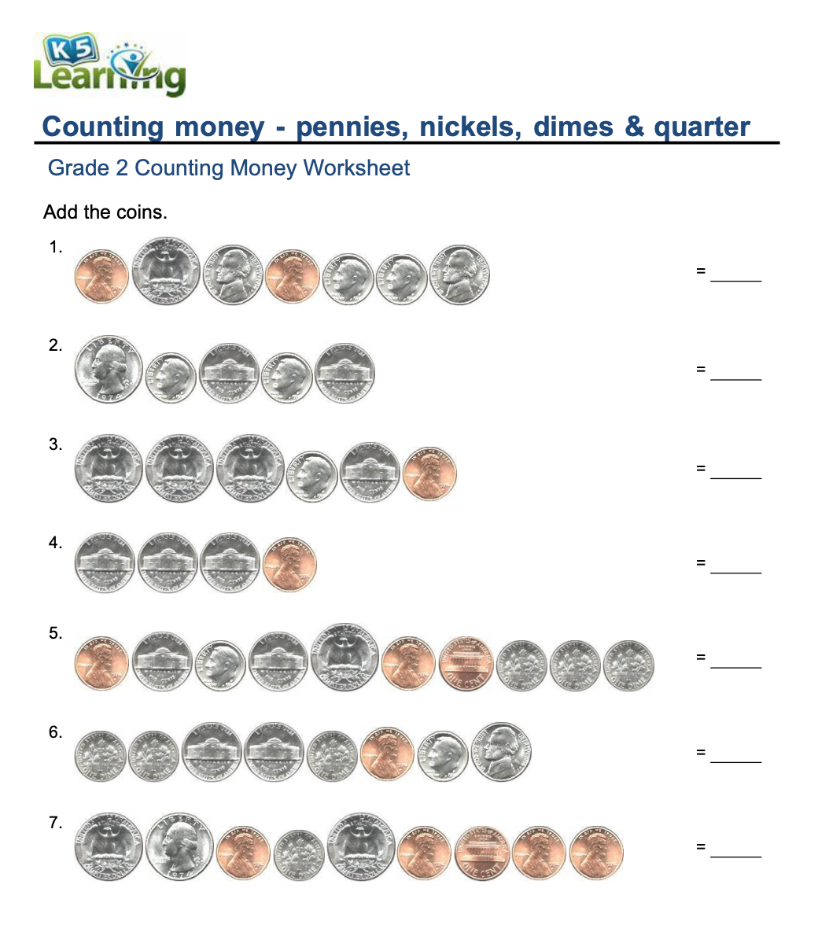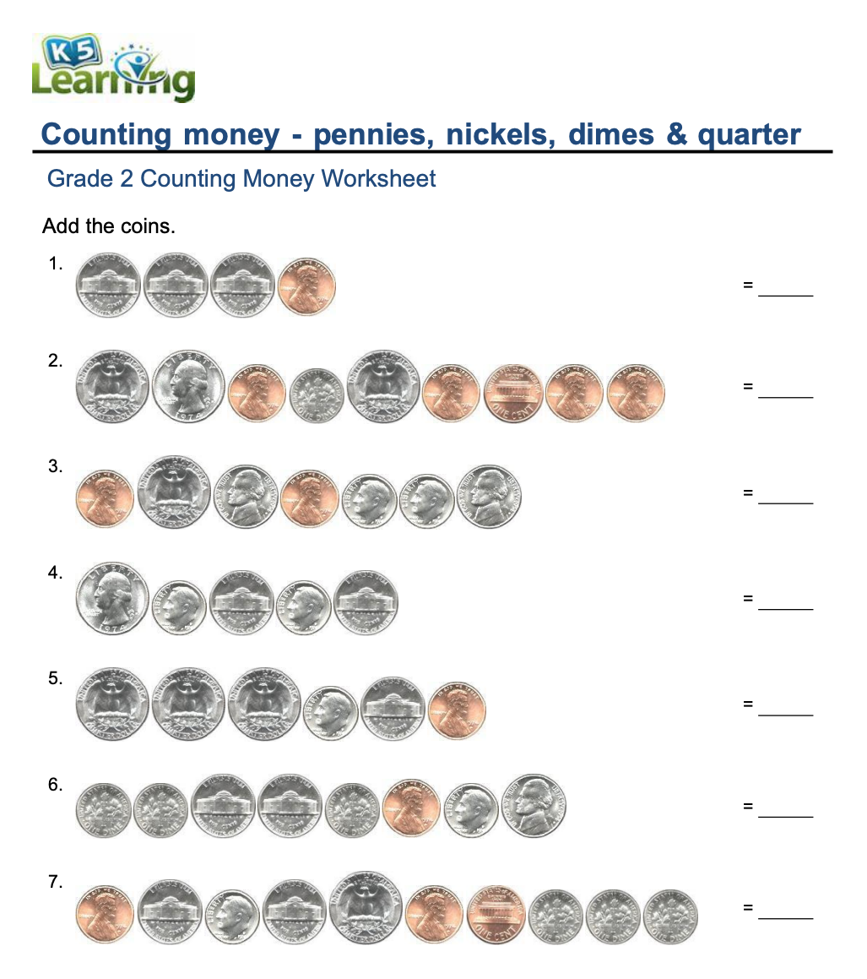

Summative Assessment Results
Student | Results | Notes
K.C. | 100% | Demonstrated full mastery
T.H. | 92.9% | 1 question answered incorrectly
B.H. | 71.4% | A significant amount of additional time and adult support were needed

Assessment Accommodations
Adult proximity and prompting are necessary for B.H. and will be offered to all students as needed. B.H. is not expected to advance as quickly as other students and will receive additional time to complete each assignment. An adult will also act as a scribe for him. All students may receive sensory breaks and one-on-one support as needed. Questions will be read aloud as requested by each individual.

Lesson Plans

Lesson Plan 1

Lesson Plan 1
Lesson Overview
Student(s)/Grade Levels | T.H. 9th grade, K.C. & B.H. 10th grade
Subject Area | Math
Lesson Goal | Students will be able to identify, solve equations, and manage U.S. currency, describe the importance of using money in daily life, and practice these skills to enhance their mathematical and practical abilities.
Lesson Objective | Students will be able to identify the name and value of U.S. coins.  Students will be able to match U.S. coins on a reference sheet.
State Standard(s) | A-2 Mathematics/Money Skills (Objective-Based Curriculum)
Annual Goal | All students in our classroom have varying IEP goals working towards transition (job skills, independent living, and life skills).
Assessment | Ongoing Progress Monitoring (CBM): | Lesson Mastery:  Students will be able to identify quarters, dimes, nickels, and pennies, both by name and monetary value.
Materials/Technology | - Coin reference sheets  - One penny, nickel, dime, and quarter for each student  - First hour binders
Accommodations/Modifications/Supports  for Diverse Learners:  Individualized Behavior Supports | - Adult proximity  - Alternative seating  - Social story about expectation when the teacher is speaking  - Modified expectations based on individual student ability

Lesson Procedures
Anticipatory Set/Background Knowledge:  - Agenda  - Share lesson objective  - Behavior expectations  - Background knowledge/Review routines  Page #: 1 Time: 3 minutes | Agenda/Daily Activities:  - Discuss the importance of being able to identify and use money.  - Introduce coin names and values.  - Practice identification together.  - Match coins to their pictures.  Lesson Objective:  - Students will be able to identify the name and value of U.S. coins.  - Students will be able to match U.S. coins on a reference sheet.  Behavior Expectations:  - Listen when the teacher or other classmates are speaking, demonstrating respect for others.  - Stay focused on activities and use time wisely.  - Work together during group activities, sharing ideas and helping each other.  - Follow instructions given by the teacher.  - Handle all classroom materials with care and put them away when finished.  - Stay positive and support classmates during learning.
Modeling Activities (I do):  Page #: 1 Time: 5 minutes | Modeling (I do):  - Teacher will display a reference sheet on the board, as well as pass one out to each student.  - Teacher will pass out one of each coin to each student so they can see a real example.  - Teacher describes the appearance and value of each coin (ascending in value), as well as how many fit within a dollar.  - Mention how $1 equals 100¢  - Teacher models how to count by coin value.  - Pennies: 1, 2, 3, 4, 5…  - Nickels: 5, 10, 15, 20, 25…  - Dimes: 10, 20, 30, 40, 50…  - Quarters: 25, 50, 75, 100
Guided Practice Activities (We do):  - Practice items  - Correction procedures  - Release of control  Page #: 1 Time: 5-10 minutes | Guided Practice Activities (We do):  - Teacher demonstrates and instructs students to fold their reference page along the vertical lines, so they only see the coin value column.  - Offer physical assistance as needed.  - Teacher holds up a penny and asks, “How much is the penny worth?”  - Teacher calls on students who raise their hand.  - If correction is needed, the teacher asks for student volunteers to agree/disagree with the answer and describe why.  - Teacher instructs students to place their penny on the matching value on their reference page.  - Teacher instructs students to count by pennies until we reach a dollar (teacher led as a whole group).  - Repeat previous steps of “Guided Practice Activities” with each coin.  - When we get to quarters, the teacher asks, “What else do we count by quarters?”  - Teacher calls on students who raise their hand.  - Expecting answers relating to the clock because when we fill out our timesheets, students color in the visual by quarters.  - If correction is needed, write numbers on the board as we count to act as a visual support.  - Teacher asks for volunteers to describe each coin’s appearance. Students may unfold and look at their reference sheet or actual coins to assist their description.  - Teacher calls on students who raise their hand.  - If correction is needed, the teacher asks for student volunteers to agree/disagree with the answer and describe why.
Independent Practice (You do):  - Practice items  - Correction procedures  Page #: 1 Time: 5-10 minutes | Independent Practice (You do):  - Teacher instructs students to fold their reference page, so they only see the pictures, and to match the coins that they have to the pictures on their reference sheet.  - Once mastered, students may move to the next step.  - Teacher instructs students to fold their reference page, so they only see the coin names, and to match the coins to the appropriate words.  - Once mastered, students may move on to the next step.  - Teacher instructs students to fold their reference page, so they only see the coin values, and to match the coins to the appropriate numbers.  - Once mastered, students are instructed to hole-punch their reference sheets and put them in their First Hour Binders.  For each step of Independent Practice:  - Teacher assesses through observation. When students are correct, the teacher provides verbal praise and mixes up the coins again.  - If correction is needed, the teacher verbally prompts individual students through the visual description.
Closure:  - Cumulative review  Page #: N/A Time: 5 minutes  - Extension activities  Page #: N/A Time: N/A  - Review lesson objective  - Preview next lesson’s topic/content | - Teacher holds up a penny and instructs students to pick up their coin that matches.  - Teacher asks for a volunteer to name the coin that they are holding and calls on someone with their hand raised.  - Teacher asks for a volunteer to describe how it looks and calls on someone with their hand raised.  - Teacher asks for a volunteer to identify the coin value in cents and calls on someone with their hand raised.  - For each of the closure steps, if correction is needed, the teacher asks for a volunteer to describe if they agree/disagree and why.  - Teacher collects coins from students.  - Teacher shows students an example of the coin foldable they will be making next week.  - Teacher instructs students to take a break before moving on to the next lesson.

Lesson 1 Implementation
I was not observed while teaching this lesson, but I feel that it went relatively well, with students successfully engaging in hands-on activities to identify the coins by name, value, and appearance. The reference sheets provided a useful visual aid, and students appreciated the tactile experience of handling real coins. The guided practice allowed for effective student participation, with many actively answering questions and matching coins to their corresponding values. One thing that went well was the implementation of individualized support and accommodations, such as adult proximity and modified expectations, which helped keep students focused and on track. Verbal praise was used effectively to encourage participation and boost confidence, but I need to focus on giving behavior specific praise rather than just saying, “Good job,” or “Nice work!”
An area for improvement would be in pacing. Since I am still getting used to teaching concepts that are not music-based, I need to practice timing everything just right. While most students were able to grasp the material, some needed additional time during independent practice, particularly when matching the coin names and values. To address this, I could consider providing more structured time for students to practice individually before moving on to the next step. Additionally, while the lesson was interactive, there were moments when some students struggled to stay focused and I could improve my classroom management strategies, possibly incorporating more frequent brain breaks or small-group discussions to maintain engagement.

Lesson 1 Results
Instructional decisions included adult proximity, modified expectations, and individualized behavior supports. I used verbal prompts and peer-assisted correction strategies to reinforce learning. The data shows that K.C. mastered the material quickly, demonstrating readiness for more advanced activities. T.H. showed strong understanding with minor errors, indicating a need for additional practice but overall competency. B.H. required extensive support, suggesting a need for scaffolding, increased individual instruction, and possibly breaking down concepts further before progressing.
Most students demonstrated proficiency in identifying U.S. coins, but differentiation will be necessary moving forward. K.C. can benefit from enrichment activities, while B.H. requires continued scaffolding and extended time. The lesson successfully introduced foundational concepts but highlighted the need for pacing adjustments and increased behavior-specific praise.

Lesson Plan 2

Lesson Plan 2

ISL Lesson 2 - Coin Foldable
Lesson Overview
Student(s)/Grade Levels | 3 students, 9th & 10th Grade
Subject Area | Math
Lesson Goal | Students will be able to identify, solve equations, and manage U.S. currency, describe the importance of using money in daily life, and practice these skills to enhance their mathematical and practical abilities.
Lesson Objective | Students will be able to identify the value of U.S. coins written in various ways.  Students will complete a foldable visual to use as a reference in future lessons.
State Standard(s) | A-2 Mathematics/Money Skills (Objective-Based Curriculum)
Annual Goal | All students in our classroom have varying IEP goals working towards transition (job skills, independent living, and life skills).
Assessment | Ongoing Progress Monitoring (CBM): | Lesson Mastery:  Students will be able to identify quarters, dimes, nickels, and pennies, both by name and monetary value.
Materials/Technology | - Coin reference sheet  - Coin foldable  - Glue
Accommodations/Modifications/Supports  for Diverse Learners:  Individualized Behavior Supports | - Adult proximity  - Alternative seating  - Modified expectations based on individual student ability

Lesson Procedures
Anticipatory Set/Background Knowledge:  - Agenda  - Share lesson objective  - Behavior expectations  - Background knowledge/Review routines  Page #: N/A Time: 5 minutes | Agenda/Daily Activities:  - Begin by reviewing coin names from the previous lesson, as well as discussing the importance of being able to identify and use money. (“Where will we need to use money in __ days?” – field trip!)  - Review using the reference sheet from our previous lesson.  - Practice identification together.  - Make a coin foldable with adult assistance as needed.  Lesson Objective:  - Students will be able to identify the value of U.S. coins written in various ways.  - Students will complete a foldable visual to use as a reference in future lessons.  Behavior Expectations:  - Listen when the teacher or other classmates are speaking, demonstrating respect for others.  - Stay focused on activities and use time wisely.  - Work together during group activities, sharing ideas and helping each other.  - Follow instructions given by the teacher.  - Handle all classroom materials with care and put them away when finished.  - Stay positive and support classmates during learning.  - Students will get out their coin reference sheets from the other day to follow along while the teacher leads the modeling activity.
Modeling Activities (I do):  Page #: N/A Time: 3 minutes | Modeling (I do):  - Teacher will show the coins on the board and review the name and value of each. Students will follow along on their reference sheet.  - Teacher will show students a completed foldable and describe what is found on the inside of each section.
Guided Practice Activities (We do):  - Practice items  - Correction procedures  - Release of control  Page #: N/A Time: 10 minutes | Guided Practice Activities (We do):  - Teacher will pass out foldables to each student and instruct students to get glue.  - Teacher will lead students as a group to complete the foldable (provide prompt and guidance as needed).  - Instruct students to open the quarter section.  - Instruct students to find the cut-out that says, “Twenty-five cents” and glue it directly above the fold.  - Instruct students to find the cut-out that says “25￠” and glue it directly beneath the fold.  - Instruct students to find the cut-out that says, “25 cents” and glue it directly beneath the previous one.  - Instruct students to find the cut-out that says “$0.25” and glue it directly beneath the previous one.  - Repeat these steps for each type of coin.  - If correction is needed, the teacher will provide the appropriate level of prompting for the individual student.
Independent Practice (You do):  - Practice items  - Correction procedures  Page #: N/A Time: 5-10 minutes | Independent Practice (You do):  - As students complete their foldables, the teacher will go around to each to assess their understanding.  - Using their completed foldables as a reference, the teacher will ask each student to identify the name and value of each coin.
Closure:  - Cumulative review  Page #: N/A Time: 5 minutes  - Review lesson objective  - Preview next lesson’s topic/content | - Teacher instructs students to put away their materials.  - Teacher asks for volunteers to identify the value of each coin.  - Teacher calls on students who raise their hand.  - If correction is needed, call on another volunteer to agree/disagree with the statement and explain why.  - Teacher tells students that they will be learning how to add coins.

Lesson 2 Implementation
The implementation of this lesson went well overall, as students were engaged and demonstrated progress in identifying and understanding the value of U.S. coins. The structured sequence of modeling, guided practice, and independent work helped reinforce learning, and students benefited from using their reference sheets as a support tool. The hands-on aspect of creating the foldable was particularly effective in keeping students engaged while providing them with a useful resource for future lessons. Additionally, reinforcing the connection between money skills and real-life applications, such as the upcoming field trip, helped make the lesson more meaningful. One area of success was the group participation, as students supported each other during the activity, and I was able to circulate and provide one-on-one assistance where needed.
One challenge was that B.H. needed significantly more time to complete the foldable, including a lot of individual assistance from me, which impacted my pacing. In future lessons, I will consider providing pre-cut materials or asking a paraprofessional to assist him while I lead the lesson. Additionally, my professor’s feedback about increasing behavior-specific feedback is something I am well aware of and want to incorporate more intentionally. I did have a great moment, praising B.H. for keeping his glue stick on the paper, but I’d like to give more specific feedback to each student. Doing so will help reinforce positive behaviors and create a more supportive learning environment. Moving forward, I will work on refining differentiation strategies to ensure that all students can fully engage with the lesson while staying on track.

Lesson 2 Results
The structured approach of modeling, guided practice, and independent work provided multiple entry points for student engagement. Adult support and peer collaboration were key components. Adjustments included providing additional individual support to B.H. and reinforcing the connection to real-world applications.
K.C. maintained full proficiency and benefited from extension discussions with a paraprofessional regarding life skills applications. T.H. improved from the previous lesson, with only minor errors that appeared to be from rushing. B.H. achieved full accuracy but required heavy support with very specific prompting. I believe that I could have structured the prompting differently for more accurate progress monitoring. The hands-on nature of the lesson helped engage all students. Students showed improved confidence and understanding of coin values in various formats. While the activity was engaging, modifications such as pre-cut materials for B.H. could improve efficiency. The lesson effectively reinforced prior knowledge and prepared students for addition exercises in Lesson 3.

Lesson Plan 3

Lesson Plan 3

ISL Lesson 3 - Sorting Coins
Lesson Overview
Student(s)/Grade Levels | 3 students, 9th & 10th Grade
Subject Area | Math
Lesson Goal | Students will be able to identify, solve equations, and manage U.S. currency, describe the importance of using money in daily life, and practice these skills to enhance their mathematical and practical abilities.
Lesson Objective | When given a worksheet and reference page, students will add U.S. coins to solve for a total monetary value.
State Standard(s) | A-2 Mathematics/Money Skills (Objective-Based Curriculum)
Annual Goal | All students in our classroom have varying IEP goals working towards transition (job skills, independent living, and life skills).
Assessment | Ongoing Progress Monitoring (CBM): | Lesson Mastery:  Students will be able to add quarters, dimes, nickels, and pennies.
Materials/Technology | - Adding coins worksheets (last page – adding pennies, nickels, dimes, and quarters – used as post-assessment)  - Coin reference sheet from previous lessons  - Pencils  - Document camera
Accommodations/Modifications/Supports  for Diverse Learners:  Individualized Behavior Supports | - Adult proximity  - Alternative seating  - Modified expectations based on individual student ability

Lesson Procedures
Anticipatory Set/Background Knowledge:  - Agenda  - Share lesson objective  - Behavior expectations  - Background knowledge/Review routines  Page #: Coin reference sheet, Time: 5 minutes | Agenda/Daily Activities:  - Begin by reviewing coin names from the previous lesson, as well as discussing the importance of being able to identify and use money. (“Where will we need to use money in __ days?” – field trip!)  - Review using the reference sheet from our previous lesson.  - Practice adding together.  - Add coins with adult assistance as needed.  Lesson Objective:  - When given a worksheet and reference page, students will add U.S. coins to solve for a total monetary value.  Behavior Expectations:  - Listen when the teacher or other classmates are speaking, demonstrating respect for others.  - Stay focused on activities and use time wisely.  - Work together during group activities, sharing ideas and helping each other.  - Follow instructions given by the teacher.  - Handle all classroom materials with care and put them away when finished.  - Stay positive and support classmates during learning.  - Students will get out their coin reference sheets from the other day to follow along while the teacher leads the modeling activity.
Modeling Activities (I do):  Page #: Coin reference sheet, adding coins worksheets, Time: 5 minutes | Modeling (I do):  - Teacher will show the coins on the board and review the name and value of each. Students will follow along on their reference sheet.  - Teacher will show and describe the worksheets that students will be working on, demonstrating an example.  - Teacher will read the directions to the students. “Identify the pictured coin and add the corresponding values.” (There is a page each for pennies, nickels, dimes, quarters, and mixed.)  - Teacher will demonstrate how to identify the coin by using the reference sheet and add together the total amount.
Guided Practice Activities (We do):  - Practice items  - Correction procedures  - Release of control  Page #: Coin reference sheet, adding coins worksheets, Time: 5-10 minutes | Guided Practice Activities (We do):  - Teacher will instruct students to get out a pencil.  - While students are gathering their materials, the teacher will pass out the worksheets  - Teacher will project the reference sheet and the adding coins worksheets.  - Pointing at the first problem (of pennies) the teacher will call on one student to identify what the coin is named and how much it is worth.  - If correct, tell the students to count how many pennies there are. If incorrect, ask for a volunteer to tell if they agree or disagree, and why. Then lead the class in adding to find the total of the pennies.  - Repeat until each student has identified a coin.  - Repeat with one problem for each worksheet.
Independent Practice (You do):  - Practice items  - Correction procedures  Page #: Coin reference sheet, adding coins worksheet, Time: 10-15 minutes | Independent Practice (You do):  - Teacher will instruct students to complete the remainder of the worksheets.  - While students are working independently, the teacher will walk between students to monitor how they are progressing.  - Teacher will help as needed.  - If the student has answered incorrectly, the teacher will demonstrate how to identify the coin name and/or value and instruct the student to try again (not giving the correct answer but guiding in the right direction).  - If the student has answered correctly, the teacher will offer verbal praise for staying focused and working hard.  - As students get closer to completing the worksheets, the teacher will instruct students to put their papers in the turn-in bin, as well as to put away their pencils.
Closure:  - Cumulative review  Page #: N/A, Time: 5 minutes  - Review lesson objective  - Preview next lesson’s topic/content | - Teacher asks for volunteers to identify the value of each coin.  - Teacher calls on students who raise their hand.  - If correction is needed, call on another volunteer to agree/disagree with the statement and explain why.  - Teacher will tell students that in the next lesson, they will learn to identify U.S. bills.

Lesson 3 Implementation
The implementation of this lesson appeared to be effective for some students, but not as effective for others. K.C. was able to finish all of the worksheets within minutes, T.H. completed them in my estimated time frame, and B.H. was unable to finish them during this lesson. He was given additional time later in the afternoon and the following day. The use of reference sheets and modeling helped to reinforce prior knowledge, making it easier for students to engage with the worksheets. The structured approach, starting with guided practice and gradually shifting to independent work, allowed students to build confidence before working on their own.
While differentiation was expected, this lesson specifically highlighted the need for additional strategies to support both faster and slower workers. In the future, I could provide extension activities for students who finish early, such as real-world money problems or interactive games, to keep them engaged while others complete their work. For students needing extra time, I could incorporate more hands-on practice with physical coins before transitioning to the worksheets. I do think, however, observing students work at different paces allowed me to focus on their behaviors. This gave me more natural opportunities to provide them with behavior-specific feedback.

Lesson 3 Results
This lesson utilized worksheets and guided practice. Visual aids, reference sheets, and step-by-step instruction supported comprehension. Accommodations were provided as needed. Adjustments in pacing and classroom management strategies were considered based on prior lessons.
K.C. demonstrated complete mastery and was ready for more complex problem-solving activities. T.H. showed strong improvement with minor calculation errors indicating a need for further reinforcement. B.H. made progress but continued to require substantial support, reinforcing the necessity for individualized scaffolding. The majority of students demonstrated significant progress in their ability to add coins. The lesson successfully built upon prior knowledge and helped to prepare students for the post-assessment.

Reflection
- Describe how your understanding of contextual factors (i.e., community, school, and students) influenced your instructional planning and assessments. Give specific examples for each.
My understanding of contextual factors, including the community, school, and students, significantly influenced my instructional planning and assessments. Paw Paw, Michigan is a small, close-knit community with strong local engagement and an emphasis on career readiness. Given the town’s economic challenges, where many families experience financial instability, I prioritized trauma-informed teaching strategies and real-world applications. This awareness shaped my decision to focus on money management skills, as these are essential for independent living.
The school’s commitment to transition planning for students with disabilities reinforced my instructional focus on life skills, ensuring that lessons were not only academically meaningful but also practical for students’ daily lives. With a small class size and diverse learning needs, I designed instruction to be highly individualized, incorporating visual aids, manipulatives, and differentiated assessment to accommodate students with cognitive impairments and other disabilities. Some students required extended time and additional support, while others benefited from extension activities that challenged them beyond the core objectives.
- Summarize the major changes that you made to your plans after receiving feedback from your cooperating teacher and your pre-assessment(s).
After receiving feedback from my cooperating teacher and analyzing pre-assessment results, I made several adjustments to my instructional plans. One major change was my approach to student feedback. Initially, I provided general praise such as, “Good job,” but my cooperating teacher and university supervisor both suggested incorporating behavior-specific praise to reinforce positive actions. I began giving targeted feedback, such as, “Great job keeping your glue stick on the paper, B.H.,” which helped students understand exactly what they were doing well.
Another significant change was pacing. The pre-assessment revealed substantial gaps in students’ prior knowledge, with scores ranging from 0% to 47%. I had originally planned to move through the unit quickly, but these results showed that students needed more time to grasp foundational concepts. In response, I adjusted the timeline, ensuring that we focused on coin identification and basic addition before introducing more complex money skills.
I also identified increased differentiation needs within my lessons, such as providing pre-cut materials and additional one-on-one support for students who needed it, while preparing enrichment activities for those who master concepts more quickly. This is another area in which I hope to continue to improve upon, as well.
- Describe how you developed the goals and objectives for your Impact on Student Learning Project.
The goals and objectives for my ISL project were developed based on our district’s objective-based curriculum, which helps to prepare students for independent living. Recognizing that money management is a vital life skill, I structured the learning objectives around identifying coins, counting money, and making transactions. Additionally, I reviewed each student’s IEP goals to ensure alignment with their individual needs.
- How did you communicate your learning expectations (i.e., goals and objectives) with students? How did you know that your students understood your learning expectations?
To communicate my learning expectations clearly, I used student-friendly language, ensuring that objectives were presented in a way that was accessible to all learners. Instead of stating, “You will need to identify the value of U.S. currency,” I reworded it to say, “You’ll learn how to recognize coins and what they’re worth.” I also relied on visual aids, such as reference sheets and real coins, to reinforce key concepts. Connecting lessons to real-life scenarios, particularly for our upcoming field trip where students will be responsible for budgeting their lunch money, helped them see the relevance of what they were learning.
To check for understanding, I used guided questioning, peer-supported discussions, and formative assessments like matching coins and adding values. By closely monitoring student participation and responses, I was able to ensure that they grasped the learning expectations.
- Describe any modifications/accommodations that you used to assure that students with special needs could meet the learning expectations?
Throughout the unit, I implemented multiple modifications and accommodations to support students with diverse needs. For students who required additional help, I provided adult proximity and frequent prompting. Extended time was given to those who needed it, and alternative response methods allowed students to demonstrate their knowledge in ways that best suited their abilities. Sensory breaks were incorporated to help students maintain focus. To ensure mastery, I also reduced the workload for students who had already demonstrated proficiency, allowing them to move on to more challenging tasks instead of repeating exercises unnecessarily.
- Describe your pre- and post-assessments and analyze the results—both for the whole class and for the three students whom you described in Item 1c.
The pre-assessment consisted of a written test covering coin identification, counting money, and making transactions. The results showed significant gaps in understanding, with K.C. scoring 30%, T.H. scoring 47%, and B.H. scoring 0%. The rest of the class scored similarly to K.C. These results highlighted the need for foundational reinforcement before moving forward. Formative assessments were integrated throughout the unit, including activities like matching coins to names and values, creating foldables for reference, and solving coin addition problems.
The post-assessment, which evaluated students’ ability to add mixed coins, showed substantial improvement. K.C. achieved 100% accuracy, demonstrating full mastery. T.H. improved to 92.9%, with only a minor error, while B.H. advanced to 71.4%, reflecting significant progress despite requiring continued support. The rest of the class scored similarly to T.H. on the post-assessment.
- Based on your analyses of your pre- and post-assessments, what conclusions can you draw about the impact that you had on your students’ learning? Be specific.
From my analysis of these assessments, I can conclude that my instructional strategies had a meaningful impact on student learning. The data indicates that hands-on learning and real-world applications improved engagement and comprehension. Differentiation was essential, as students like B.H. required extensive scaffolding, while K.C. benefited from extension activities. Providing behavior-specific feedback also helped reinforce positive learning behaviors. Adjusting the pacing of lessons ensured that students had the time needed to master concepts before moving on.
Ultimately, students not only improved their ability to identify and count money, but they also gained confidence in using these skills in everyday situations. By focusing on practical, real-world applications and providing individualized support, I was able to help my students make meaningful progress in their financial literacy and independence.

References
Paw Paw Public School District. (n.d.). General information: Paw Paw public school district.
MI School Data. (2024). Paw Paw High School special education data portraits: Disability.
MI School Data. (2024). Paw Paw High School student enrollment counts report.
MI School Data. (2024). Paw Paw High School parent dashboard for school transparency.
U.S. Census Bureau. (2023). American Community Survey 5-year estimates.

